Risk management in insurance industry

Tusarkanta Kar

FINAL THESIS REPORT

October 2021

**DEDICATION**

I dedicate this thesis to my loving family, whose unwavering support and encouragement have been my driving force throughout this academic journey. To my parents, for their sacrifices and endless belief in my potential. To my siblings, for their understanding and patience during my countless late nights of study. To my friends, who provided much-needed laughter and respite. Finally, to my mentors and professors, for their guidance and wisdom. This work is a tribute to all of you, as you've been the foundation of my success. With heartfelt gratitude, Tusarkanta Kar.

**ACKNOWLEDGEMENTS**

I would like to express my sincere gratitude to the many individuals who have contributed to the successful completion of this thesis. First and foremost, I am deeply thankful to my supervisor, Dr. Rituparna Dutta, whose guidance, expertise, and unwavering support have been invaluable throughout this research journey. Your mentorship has been instrumental in shaping this thesis.

I also extend my appreciation to the faculty members of the LJMU, whose lectures and discussions broadened my understanding of the subject matter. Their dedication to fostering a stimulating academic environment was essential to my growth as a researcher.

Lastly, I express my gratitude to my family and friends for their unwavering encouragement and understanding during this demanding period. This thesis is a product of collective effort, and I am thankful for the contributions and support of every person who played a part in its completion.

**ABSTRACT**

An insurance company becomes responsible for handling risk/risks on behalf of its clients i.e., the insured, in exchange for a periodic sum of money called premium. A premium is the sum paid by the insured to the insurer in compliance with an insurance contract. If risk portfolio is extremely high compared to the capital of the company, it can transfer the risk (and premium) over to other companies, its reinsurers. Remainder of the risk that stays with the insurance company, that has signed an insurance contract with the insured, is called retention. Of course, the risks of the reinsurers can be transferred further to the next level of reinsurers. As a result, the initial risk is covered by a complete net of insurance and reinsurance from many insurance firms, each with its own retention. The challenge of actuarial mathematics is determining the size of retention and pay based on several aspects.

The current research proposed here will be focused on investigation of the mathematical structure of retention (and compensation) function which intrinsically depends on capital, earning, propensity to take risks by an insurance farm, and risk nonalignment. We discuss the monotonicity and support of retention functions to show that a certain type of functions qualifies as retention function under the assumption of linearization. Especially, the first order truncated Taylor series of a number of nonlinear functions can qualify as retention functions and Linear programming (LP) can be used to quickly determine the efficient portfolio formation for a reinsurer. Most importantly, we contradict the common perception in modelling reinsurance that the reinsurer should take the risk himself. Instead, in many practical cases, using the mathematical retention and compensation function, that division of risks at the level of reinsurance firms can be useful for risk reduction. Especially, given the constituent risks of PF2 type (Polya frequency function of order 2), the overall risk involved in the reinsurance contract is also PF2 type, and less than (or equal to) the sum of individual risks involved. Consequently, the reinsurer efficiency increases. We provide analysis for two use cases to show how machine learning strategies can help the business analytics of reinsurance farms using the proposed model.

# TABLES OF CONTENTS

1. Introduction 8

2. Literature review 19

3. Research Methodology 27

4. Analysis 38

5. Result and discussions 49

6. Conclusion and recommendation 63

7. References 68

# LIST OF FIGURES

Figure 1 Risk Management in insurance and Reinsurance: a schematic 10

Figure 2 Example of PFn functions 24

Figure 3 Risk Management in Reinsurance: a Pareto chart for linearized problems 49

Figure 4: Example of Pareto front solutions resembling rectangular hyperbola 49

Figure 5: Various Retention and compensation profiles for bivariate claims 50

Figure 6: Risk reduction by multi-objective optimization for Pareto solutions 55

Figure 7: Risk Management through risk matrix structure 56

CHAPTER 1

INTRODUCTION

Reinsurance is a mechanism used by insurance companies to transfer a portion of their risk to another insurer, known as the reinsurer. It is a contractual arrangement where the reinsurer agrees to indemnify the insurer for losses incurred on the policies it has underwritten. The primary purpose of reinsurance is to help insurance companies manage their exposure to risks and protect their financial stability. By transferring a portion of their risks to a reinsurer, insurance companies can reduce their potential losses in the event of large and catastrophic claims. Reinsurance allows insurers to spread the risk across multiple parties, thereby mitigating the impact of individual losses.

Reinsurers provide coverage to insurers through various reinsurance structures, including proportional and non-proportional treaties, facultative reinsurance, and excess of loss agreements. In proportional reinsurance, the reinsurer shares a proportional portion of the premiums and losses with the insurer. In non-proportional reinsurance, the reinsurer covers losses that exceed a specific threshold. Facultative reinsurance involves individually underwriting specific risks. Excess of loss reinsurance provides coverage for losses that exceed a predetermined limit. Reinsurance plays a vital role in the insurance industry by providing insurers with financial stability, capacity to underwrite larger risks, and protection against catastrophic events. It also helps insurers meet regulatory requirements, maintain solvency, and enhance their ability to offer coverage to policyholders [1,2]. Reinsurers, in turn, earn premiums from providing coverage and manage their own risks through diversification and underwriting expertise. Overall, reinsurance serves as a crucial tool for insurers to manage their risks and ensure the long-term sustainability of the insurance industry.

Risk management in reinsurance refers to the process of identifying, assessing, and managing risks associated with reinsuring insurance policies. Reinsurance is a mechanism used by insurance companies to transfer a portion of their risk to another insurer, known as the reinsurer. The main objectives of risk management in reinsurance are to protect the reinsurer from excessive exposure to losses and to ensure the stability and profitability of the reinsurance business. This involves various activities including:

**1.1 Risk Identification:** Identifying and analyzing potential risks that can impact the reinsurer's financial stability, such as catastrophic events, economic downturns, or changes in regulatory requirements. Catastrophic events, such as natural disasters, can lead to significant losses for insurance companies and reinsurers. Identifying and assessing catastrophe risks involves analyzing historical data, using catastrophe model, and considering factors such as geographic exposure, vulnerability, and frequency of events .

Insurance companies and reinsurers typically invest premiums received from policyholders to generate income and meet future obligations. Identifying and managing investment risks involves assessing market volatility, credit risk, liquidity risk, and interest rate fluctuations. Reinsurance involves credit risk, which refers to the potential for the reinsurer to default on its obligations. Identifying and assessing credit risk involves evaluating the financial strength and creditworthiness of reinsurers before entering into reinsurance agreements. Compliance with regulatory requirements and changes in legal frameworks can also pose risks to insurance companies and reinsurers. Identifying and monitoring regulatory and legal risks helps ensure compliance and mitigate potential penalties or legal disputes. Further, operational risks arise from internal processes, systems, and human error. Identifying and managing operational risks involves assessing areas such as claims processing, data management, cybersecurity, and business continuity planning. Reinsurance companies face reputational risks from negative publicity, customer dissatisfaction, or unethical behaviour. Identifying and mitigating reputational risks involves monitoring industry trends, managing customer relationships, and maintaining high ethical standards.

Risk identification in reinsurance often involves a combination of quantitative and qualitative analysis. It requires collecting and analyzing data, conducting risk assessments, and considering various scenarios and potential impacts. By identifying and understanding these risks, insurance companies and reinsurers can develop appropriate risk management strategies to protect their financial stability and ensure their ability to meet policyholder obligations. The following factors have been described in [8,9] as main influencing factors.

**1.2 Risk Assessment:** Evaluating the likelihood and potential impact of identified risks to determine their significance and prioritize them accordingly. Insurance companies and reinsurers employ rigorous underwriting processes and risk assessment techniques to evaluate and select policies and risks. Thorough analysis of potential risks helps to identify and avoid high-risk or adverse selection situations, thereby reducing the overall risk exposure. Reinsurers often use sophisticated catastrophe modelling and risk analysis tools to assess the potential impact of catastrophic events, such as natural disasters. These models help in pricing reinsurance contracts appropriately and setting appropriate risk retention levels.

**1.3 Risk Mitigation:** Implementing strategies and measures to reduce or control the identified risks. This can involve diversifying the reinsurer's portfolio, setting appropriate underwriting guidelines, or establishing risk limits. It involves transferring a portion of the risk to a reinsurer, which helps protect the financial stability of the insurance company and ensures that it can fulfill its obligations to policyholders. By purchasing reinsurance, an insurance company transfers a portion of its risk exposure to a reinsurer. This helps to diversify and spread the risk across multiple entities, reducing the potential financial impact of large losses. Reinsurance allows for risk sharing between the insurance company and the reinsurer. The insurance company retains a portion of the risk, known as the "retention," while transferring the remaining risk to the reinsurer. This sharing of risk helps to limit the exposure of the insurance company and provides a financial buffer in the event of significant claims. Insurance companies and reinsurers carefully manage their portfolios to ensure a balanced distribution of risk. They consider factors such as geographic location, policy types, coverage limits, and industry sectors to diversify their exposure. This diversification helps to mitigate the impact of localized or sector-specific losses.

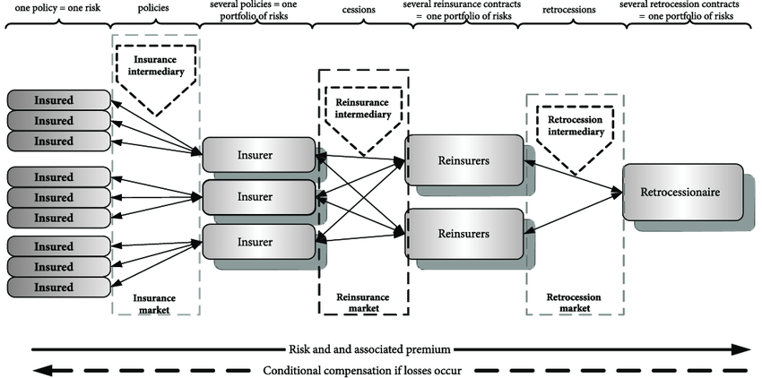

**Figure 1: Risk Management in insurance and Reinsurance: a schematic**

**1.4 Risk Transfer:** Transferring a portion of the risks (see Fig. 1) to other reinsurers or capital markets through various reinsurance structures, such as proportional or non-proportional treaties, facultative reinsurance, or catastrophe bonds. Reinsurance contracts include specific provisions and clauses that outline the terms and conditions of risk transfer, including limits, deductibles, and coverage restrictions. These provisions help to define the scope of risk assumed by the reinsurer and provide clarity in the event of a claim.

**1.5 Monitoring and Reporting:** Continuously monitoring the performance and exposure to risks, and regularly reporting to stakeholders, including regulators, rating agencies, and reinsured companies.

Effective risk management in reinsurance is crucial for reinsurers to maintain financial stability, meet regulatory requirements, and fulfill their obligations to reinsured companies. It helps them protect against unexpected losses, optimize their capital allocation, and ensure their long-term sustainability in the market. There are several models of risk reduction in reinsurance that insurers can utilize to manage their exposure to risks. Some common models include:

Proportional Reinsurance: In this model, the reinsurer and insurer share the premiums and losses in a proportionate manner. This can be done on a quota share basis, where the reinsurer takes a fixed percentage of each policy, or on a surplus share basis, where the reinsurer takes a percentage of the surplus on each policy. Proportional reinsurance helps insurers reduce their risk exposure by spreading it across multiple parties.

**1.6 Non-Proportional Reinsurance:** Non-proportional reinsurance involves the reinsurer covering losses that exceed a specific threshold, such as an aggregate deductible or a per-occurrence limit. This model provides coverage for catastrophic events or large losses. Non-proportional reinsurance can be structured as excess of loss or stop-loss agreements.

**Catastrophe Reinsurance:** Catastrophe reinsurance specifically focuses on protecting insurers against losses resulting from large-scale catastrophic events, such as earthquakes, hurricanes, or floods. Catastrophe reinsurance provides coverage for losses that exceed a predetermined threshold, often referred to as a "per-event" or "per-occurrence" limit.

**Facultative Reinsurance:** Facultative reinsurance involves individually underwriting specific risks on a case-by-case basis. Insurers can choose to cede a portion of the risk to the reinsurer based on their underwriting criteria. Facultative reinsurance allows insurers to manage their exposure to high-risk or unique policies.

**Retrocession:** Retrocession is a form of reinsurance where reinsurers transfer a portion of their risk to another reinsurer. This is typically done when the original reinsurer wants to reduce its own exposure or diversify its risk portfolio. Retrocession can be structured in various ways, including proportional and non-proportional arrangements.

**Alternative Risk Transfer (ART) Solutions:** ART solutions involve innovative reinsurance structures that go beyond traditional models. These can include insurance-linked securities (ILS), such as catastrophe bonds or insurance-linked notes, which transfer risks to capital market investors. ART solutions provide additional capacity and diversification options for insurers.

It's important to note that insurers often use a combination of these models to create a comprehensive and diversified reinsurance program that suits their specific risk management needs. The choice of models depends on factors such as the insurer's risk appetite, the type of risks being insured, and the market conditions.

While models of risk reduction in reinsurance offer valuable tools for insurers to manage their exposure to risks, they also have some shortcomings that should be considered.

**1.7 Some of the shortcomings include:**

**Basis Risk:** Basis risk refers to the potential mismatch between the insurer's underlying risks and the risks covered by the reinsurance contract. There may be differences in policy terms, coverage limits, or triggers that can result in gaps in coverage. Insurers need to carefully assess and manage basis risk to ensure effective risk reduction.

**Counterparty Risk:** Reinsurance involves entering into contractual agreements with reinsurers. Insurers are exposed to counterparty risk, which is the risk that the reinsurer may not fulfill its obligations in the event of a claim. Insurers should conduct due diligence on the financial strength and reputation of the reinsurer to mitigate counterparty risk.

**Pricing and Affordability:** Reinsurance premiums are determined based on the level of risk transferred. However, pricing can be complex, and obtaining affordable reinsurance coverage may be challenging, especially for high-risk or niche markets. Insurers need to strike a balance between risk reduction and cost-effectiveness.

**Capacity Limitations:** Reinsurers have their own risk appetite and capacity limits. Insurers may face challenges in finding suitable reinsurers willing to take on their risks, especially for large or complex risks. This can limit the availability of reinsurance coverage and potentially leave insurers exposed to significant losses.

**Regulatory and Legal Considerations:** Different jurisdictions may have varying regulatory requirements and legal frameworks for reinsurance. Insurers need to ensure compliance with these regulations and consider any legal implications of their reinsurance arrangements.

**Over-reliance on Reinsurance:** While reinsurance provides risk reduction, over-reliance on reinsurance can create a false sense of security. Insurers should not solely rely on reinsurance as their primary risk management tool. It is important for insurers to maintain appropriate underwriting practices, risk diversification, and sound financial management.

To mitigate these shortcomings, insurers should carefully assess their risk management strategies, conduct thorough due diligence on reinsurers, diversify their reinsurance program, and regularly monitor and review their reinsurance arrangements [15,16] to ensure they align with their risk management objectives.

The network of insurance and reinsurance plays a crucial role in risk management and sharing across various industries and sectors. Here's an overview of how insurance and reinsurance work together to facilitate risk transfer and mitigation:

**1.8 Insurance Companies:**

Insurance companies provide insurance policies to individuals, businesses, and organizations to protect against specific risks. Policyholders pay premiums to the insurance company in exchange for coverage.

Insurance policies cover a wide range of risks, including property damage, liability, health, life, and more.

Insurance companies collect premiums from policyholders, pool the funds, and use them to pay out claims when policyholders experience covered losses or events.

**1.9 Reinsurance Companies:**

Reinsurance companies, often referred to as reinsurers, serve as a form of insurance for insurance companies. They help spread and manage the risk assumed by primary insurers.

Insurance companies purchase reinsurance policies to protect themselves from catastrophic losses that might exceed their financial capacity. Reinsurance allows insurers to share the risk with other companies.

Reinsurers collect premiums from insurance companies and, in return, agree to cover a portion of the insurance company's losses if they exceed a specified threshold.

**1.10 Risk Sharing:**

Insurance companies share risk with policyholders, who pay premiums in exchange for financial protection in the event of covered losses.

Reinsurance companies share risk with primary insurers. When primary insurers face large or unexpected claims, reinsurance helps absorb some of the financial impact, ensuring the stability of the primary insurer's operations.

The network of insurance and reinsurance companies creates a multi-layered risk-sharing system, allowing risk to be distributed across a broader spectrum of entities.

**1.11 Types of Reinsurance:**

There are various types of reinsurance arrangements, including proportional reinsurance and non-proportional reinsurance. Proportional reinsurance involves sharing a portion of premiums and claims in proportion to the reinsurer's share of the risk. This type of reinsurance is often used for less volatile risks.

Non-proportional reinsurance, such as excess of loss reinsurance, covers losses that exceed a predefined threshold. It is typically used for catastrophic events and provides protection against large, unexpected losses.

**1.12 Global Network**The insurance and reinsurance industry operates globally, with reinsurers providing coverage to insurers and insurers offering policies to clients worldwide.

This global network of insurers and reinsurers allows for risk diversification and helps stabilize the industry by spreading risk across different regions and markets.

**Regulation and Oversight:** Insurance and reinsurance industries are subject to regulatory oversight to ensure financial stability and consumer protection. Regulations vary by country and region.

Famous insurance companies, also known as major insurers, handle risk through a combination of underwriting, risk assessment, and reinsurance. These companies have extensive experience and resources to manage and mitigate risks effectively. Major insurers employ underwriters and risk assessors who thoroughly evaluate insurance applications. They assess various factors, including the applicant's risk profile, claims history, coverage needs, and the nature of the insured asset or liability. Insurers use actuarial and statistical models to price insurance policies appropriately. Premiums are calculated based on the assessed risk, with higher-risk policies commanding higher premiums. Major insurers often have diverse portfolios that include a wide range of insurance products, such as property and casualty, life, health, and specialty lines. This diversification helps spread risk across different categories and minimizes the impact of losses in any one area. Major insurers maintain significant financial reserves to cover potential claims. They are required by regulatory authorities to maintain a certain level of capital to ensure their ability to meet their obligations to policyholders.

Reinsurance is a crucial risk management tool for major insurers. They purchase reinsurance policies to protect themselves from catastrophic losses and to manage their exposure to risk. Major insurers work with reinsurance companies to create a reinsurance program that suits their needs. This program may include proportional reinsurance, non-proportional reinsurance, or a combination of both. Reinsurance allows insurers to transfer a portion of their risk to reinsurers. In the event of large claims or catastrophic events, the reinsurer helps cover the costs, reducing the financial burden on the insurer.

Major insurers often have risk management and loss control services that provide guidance to policyholders on how to reduce their exposure to risks. This may involve implementing safety measures, improving security, or making changes to minimize potential losses. Many major insurers invest in advanced technology and data analytics to assess and predict risks more accurately. They use data-driven insights to refine underwriting practices, detect fraudulent claims, and optimize risk portfolios. At all times, compliance with regulatory requirements is a top priority for major insurers. They work closely with regulators to ensure that they meet capital adequacy and solvency standards, which are essential for maintaining financial stability. Major insurers often provide educational resources to policyholders to help them understand their coverage and risk management options. Informed policyholders are better equipped to manage their risks effectively.Insurers have dedicated claims departments that handle claims efficiently and fairly. Timely claims processing is essential to maintaining customer trust. Claim management forms an integral part o insurance and reinsurance business. Note that many major insurers have a global presence, which allows them to operate in multiple markets and diversify their risk exposure across different regions and industries. Famous insurance companies combine sound risk management practices, diversification, financial strength, and reinsurance to handle and mitigate risks effectively. Their goal is to provide policyholders with financial protection while ensuring the long-term stability and sustainability of their operations.

Several famous reinsurance companies operate globally, playing a crucial role in the risk management ecosystem. Here are some of the well-known reinsurance companies and descriptions of their risk management approaches:

**Munich Re:** Munich Re, headquartered in Germany, is one of the world's largest reinsurance companies. They have a reputation for comprehensive risk management. Munich Re's approach involves using advanced modeling and analytics to assess risk accurately. They focus on diversifying their portfolio across various geographic regions and lines of business. Additionally, they collaborate with clients to develop tailored risk solutions and offer expert guidance on risk mitigation.

**Swiss Re:** Swiss Re, based in Switzerland, is another global reinsurance leader. They employ a forward-looking risk management strategy that combines quantitative risk modeling, extensive research, and scenario analysis. Swiss Re actively collaborates with primary insurers to develop innovative risk transfer solutions. They also provide risk engineering services to help clients reduce exposure to loss events and improve resilience.

**Hannover Re:** Hannover Re, a German reinsurance company, focuses on underwriting risks selectively. They emphasize conservative risk management, including rigorous underwriting standards and prudent investment strategies. Hannover Re diversifies its portfolio across regions and business lines and maintains strong financial reserves to withstand adverse events.

**Berkshire Hathaway Reinsurance Group:** A subsidiary of Warren Buffett's Berkshire Hathaway, this reinsurance group takes a long-term approach to risk management. They prioritize underwriting discipline and pricing accuracy, avoiding risks that do not meet their criteria. Berkshire Hathaway Reinsurance Group's financial strength allows them to provide capacity for large and complex risks, and their investment strategy helps maintain financial stability.

**SCOR:** SCOR, a French reinsurer, is known for its global presence and risk management expertise. They employ a four-pillar risk management framework: risk underwriting, risk modeling, risk monitoring, and risk transfer. SCOR also focuses on ESG (Environmental, Social, and Governance) factors in their risk assessment and has a strong commitment to sustainability.

**Reinsurance Group of America (RGA):** RGA, based in the United States, specializes in life and health reinsurance. Their risk management approach involves tailoring reinsurance solutions to address specific risks within the life insurance industry. They emphasize innovation and collaborate closely with primary insurers to develop customized solutions.

**Everest Re Group:** Everest Re, headquartered in Bermuda, has a diversified portfolio that includes property and casualty reinsurance. Their risk management strategy includes thorough underwriting, disciplined pricing, and active portfolio management. They use advanced analytics to assess risk and monitor market conditions to adapt to changing circumstances.

These reinsurance companies have earned their reputations through disciplined risk management practices, financial strength, and a commitment to helping primary insurers and clients manage their exposures effectively. Their expertise in assessing and mitigating risk is instrumental in ensuring the stability and resilience of the global insurance industry.

Regulators often require insurance companies to maintain sufficient capital to cover potential losses, including those that might be incurred by reinsured risks. Overall, the network of insurance and reinsurance is essential for managing and mitigating risk in various sectors, from property and casualty insurance to life insurance and beyond. It helps ensure that individuals, businesses, and organizations can obtain coverage for a wide range of risks while maintaining financial stability in the face of unexpected events.

Several prominent reinsurance companies operate in Asia, providing essential risk management services to the insurance industry in the region. Here are descriptions of some of the well-known Asian reinsurance companies and their risk management approaches:

**Asian Reinsurance Corporation (Asian Re):**

Asian Re, headquartered in Bangkok, Thailand, is a leading reinsurance company in Asia. Their risk management strategy focuses on a diversified portfolio that includes both life and non-life reinsurance. They prioritize underwriting discipline and employ advanced risk modeling techniques to assess and manage risk accurately. Asian Re actively collaborates with primary insurers to develop customized reinsurance solutions tailored to their specific needs.

**Korean Reinsurance Company (Korean Re):**

Korean Re, based in Seoul, South Korea, is a major player in the Asian reinsurance market. Their risk management approach emphasizes prudent underwriting practices and comprehensive risk assessment. Korean Re provides a wide range of reinsurance products, including property and casualty, life, and specialty lines. They have a strong focus on customer satisfaction and aim to offer flexible and responsive risk transfer solutions.

**China Reinsurance (Group) Corporation (China Re):**

China Re, headquartered in Beijing, China, is one of the largest reinsurance companies in Asia and has a significant global presence. Their risk management strategy encompasses a broad spectrum of insurance and reinsurance products, including property, life, and specialty lines. China Re leverages advanced technology and data analytics for risk assessment and actively participates in international risk pools and collaborations to manage large-scale risks effectively.

**Munich Re Asia:**

Munich Re, a global reinsurance leader based in Germany, has a strong presence in Asia through Munich Re Asia. They emphasize local market expertise and collaborate closely with Asian insurers and clients. Munich Re Asia employs advanced risk modeling and analytics to assess and mitigate risk effectively. They also focus on innovation and offer tailored reinsurance solutions to address emerging risks in the Asian market.

**Toa Reinsurance Company Limited (Toa Re):**

Toa Re, headquartered in Tokyo, Japan, is a well-established reinsurance company in Asia. Their risk management approach centers on disciplined underwriting and a commitment to long-term stability. Toa Re provides reinsurance solutions for property and casualty risks, as well as specialty lines. They prioritize risk diversification and prudent investment strategies to ensure financial resilience.

**General Insurance Corporation of India (GIC Re):**

GIC Re, based in Mumbai, India, is the national reinsurer of India and a significant player in the Asian reinsurance industry. Their risk management strategy involves a comprehensive portfolio that includes property, marine, aviation, and other lines of business. GIC Re places a strong emphasis on risk assessment and uses advanced modeling techniques to manage risk effectively. They have a global presence and collaborate with insurers worldwide.

These Asian reinsurance companies are recognized for their commitment to sound risk management practices, financial strength, and their role in supporting the growth and stability of the insurance industry across the Asian continent. They play a critical role in helping insurers manage and transfer risk effectively in a region with diverse and evolving insurance needs. Governments often play a significant role in the reinsurance industry, both as purchasers of reinsurance coverage and as regulators overseeing the insurance and reinsurance sectors. Here's how governments are involved in reinsurance:

**1.13 Purchasers of Reinsurance:**

Catastrophic Risk Management: Governments at various levels (national, state, or local) may purchase reinsurance to manage catastrophic risks. This is particularly common for risks related to natural disasters such as hurricanes, earthquakes, and floods. Reinsurance can help governments cover the financial costs of disaster response, recovery, and reconstruction.

Healthcare and Social Programs: Some governments, especially those with national healthcare systems or social insurance programs, may purchase reinsurance to protect against unexpected spikes in healthcare or social benefit costs. Reinsurance can help stabilize budgets and ensure the sustainability of these programs.

**Export Credit and Trade Promotion:** Governments may support their country's exporters by providing export credit insurance or guarantees. Reinsurance can be used to spread the risk associated with these programs, encouraging trade and economic growth.

**1.14 Regulatory Oversight:**

**Financial Regulation:** Governments typically regulate the insurance and reinsurance industries to ensure their financial stability and protect policyholders and the broader economy. Regulatory agencies set capital and solvency requirements for insurers and reinsurers to ensure they can meet their obligations to policyholders.

**Market Conduct:** Regulatory authorities oversee the conduct of insurers and reinsurers to ensure fair and ethical practices. They investigate complaints, monitor compliance with consumer protection laws, and enforce industry standards.

**Consumer Protection:** Governments may establish and enforce rules and regulations to protect consumers who purchase insurance or reinsurance products. This includes ensuring transparency, fair pricing, and claims handling practices.

**Public-Private Partnerships:**

Governments often work in partnership with the private reinsurance industry to develop risk-sharing mechanisms and programs. These partnerships can help ensure that insurance and reinsurance are available and affordable, especially for high-risk areas or vulnerable populations.

**Market Stabilization:**

In times of financial crisis or market instability, governments may intervene to stabilize the insurance and reinsurance sectors. They may provide support or guarantees to help ensure the continued availability of reinsurance coverage during crises.

**Risk Mitigation and Resilience:**

Governments may incentivize risk mitigation and resilience-building efforts. Reinsurance can be used as a tool to encourage investments in disaster-resistant infrastructure and preparedness measures.

**Policyholder Protection:**

Governments may establish insurance guarantee funds or schemes to protect policyholders in case an insurer or reinsurer becomes insolvent. These funds are often funded by the industry and can provide a safety net for policyholders.

Overall, governments and reinsurance are closely interconnected, with governments using reinsurance as a risk management tool and reinsurers working within the regulatory framework established by governments. This collaboration helps ensure the stability and availability of insurance and reinsurance coverage for various risks, from natural disasters to healthcare costs and beyond. Recession can have significant implications for the reinsurance industry, and effective risk management becomes even more critical during economic downturns. Here are some key considerations for risk management in reinsurance during a recession:

**Portfolio Diversification:**

Reinsurers should maintain diversified portfolios across different lines of business and geographic regions. This diversification helps spread risk and reduces exposure to the impact of economic downturns in specific sectors or regions.

**Underwriting Discipline:**

During a recession, it's essential to maintain strict underwriting discipline. Reinsurers should carefully evaluate new business opportunities, ensuring that the risks being underwritten align with the company's risk appetite and financial capabilities.

**1.15 Claims Management:**

Effective claims management is critical. Reinsurers should have robust claims handling processes to assess and settle claims promptly and fairly. Managing claims efficiently helps maintain trust with ceding insurers and policyholders.

**Capital Adequacy:**

Reinsurers must closely monitor their capital adequacy. Economic downturns can affect investment portfolios, which may impact a reinsurer's solvency. Reinsurers should have contingency plans in place to address potential capital shortfalls.

**Reserving Practices:**

Conservative reserving practices are crucial. Reinsurers should regularly assess their loss reserves to ensure they accurately reflect potential future liabilities. Adequate reserves are essential for financial stability.

**Risk Modeling and Analytics:**

Advanced risk modeling and analytics can help reinsurers assess and manage risk more effectively. During a recession, these tools can be particularly valuable in evaluating the impact of economic factors on the reinsurance portfolio.

**Asset Management:**

Reinsurers often have investment portfolios that generate income to support their underwriting activities. During a recession, it's essential to carefully manage investment portfolios, considering factors such as credit risk and liquidity.

**Market Intelligence:**

Staying informed about economic conditions, industry trends, and market developments is crucial. Reinsurers should closely monitor the financial health of ceding insurers and adjust their risk exposure accordingly.

**Collaboration with Clients:**

Reinsurers should maintain open lines of communication with ceding insurers and clients. Understanding their challenges and needs can help tailor reinsurance solutions that address their specific risk management requirements during economic downturns.

**Innovation and Product Development:**

Reinsurers can explore innovative risk transfer solutions to meet evolving client needs. During a recession, there may be increased demand for tailored reinsurance products that address emerging risks.

**Regulatory Compliance:**

Reinsurers must adhere to regulatory requirements and report financial data accurately. Regulatory authorities may provide guidance or relief measures during economic crises, and reinsurers should stay informed about regulatory changes.

**Scenario Planning:**

Developing scenarios and stress tests can help reinsurers assess their resilience to various economic downturn scenarios. This planning allows them to proactively address potential challenges.

Recession-related risks can affect different lines of business and regions differently, so a flexible and adaptive risk management strategy is essential. Reinsurers that implement effective risk management practices can navigate economic downturns more successfully, maintain financial stability, and continue to provide valuable risk transfer solutions to their clients. let's delve deeper into how the reinsurance industry can implement specific risk management strategies during a recession:

**Portfolio Diversification:**

Reinsurers should not concentrate their risk exposure in a single sector or region. Diversifying across various lines of business (e.g., property, casualty, life) and geographic areas helps mitigate the impact of an economic downturn in any one sector or region.

**Underwriting Discipline:**

Maintaining strict underwriting discipline is essential. Reinsurers should avoid underpricing risks due to competitive pressures during a recession. They must ensure that the premiums they charge accurately reflect the risks being assumed.

**Claims Management:**

During a recession, there may be an uptick in insurance claims as policyholders seek coverage for financial losses. Reinsurers must have efficient claims management processes in place to handle increased claim volumes promptly and fairly.

**Capital Adequacy:**

Reinsurers should regularly assess their capital adequacy, considering potential investment losses and increased claims payouts during economic downturns. Stress testing can help determine the sufficiency of capital reserves.

**Reserving Practices:**

Reinsurers need to maintain conservative reserving practices to ensure they have adequate reserves to cover potential future liabilities, including unexpected claim surges that may occur during a recession.

CHAPTER 2

LITERATURE REVIEW

While mathematics plays a crucial role in risk reduction in reinsurance, there are some shortcomings and challenges associated with its application. Some of the shortcomings in the mathematics of risk reduction in reinsurance include:

The accuracy and reliability of risk models heavily depend on the quality and quantity of data available. In some cases, historical data may be limited, especially for emerging or rare risks. Insufficient or incomplete data can lead to inaccuracies in risk assessment and modeling, potentially impacting the effectiveness of risk reduction strategies. Risk models often rely on assumptions and simplifications to make calculations more manageable. However, these assumptions may not always accurately reflect the complexities and uncertainties of real-world risks. Oversimplification can lead to inaccurate risk projections and inadequate risk reduction measures.

Risk models are based on statistical analysis and probability theory, which inherently involve uncertainties. The future occurrence of catastrophic events or other unforeseen circumstances may deviate significantly from historical patterns, making it challenging to accurately quantify and manage risks. Risk models often assume independence of risks, but in reality, risks can be correlated or dependent on each other. Ignoring or underestimating the interdependencies between risks can lead to inaccuracies in risk assessment and the effectiveness of risk reduction strategies.

Moreover, the selection and calibration of risk models involve inherent limitations and potential biases. Different models can produce different results, and the choice of a particular model may introduce model risk. It is essential for insurers to understand and validate the models used in risk reduction to ensure their reliability and appropriateness. Note that Mathematics and risk models are tools that rely on human interpretation and decision-making. Human biases, errors, or misinterpretations can impact the effectiveness of risk reduction strategies. It is crucial to have skilled and experienced professionals who can appropriately apply mathematical models and interpret their results.

To mitigate these shortcomings, insurers should regularly review and update their risk models, incorporate exact quantitative analysis with sensitivity metric to assess the impact of uncertainties, and continuously improve data quality and availability. It is important to recognize that mathematics is a valuable tool, but it should be used in conjunction with physical considerations regarding risk management theory to ensure comprehensive and effective risk reduction in reinsurance. Especially, the physical properties of a risk model in reinsurance should clearly outline the mathematical properties of retention and compensation which is defined below from established risk management practice in reinsurance. Note the minimization of risk of ten involves extremizing these functions (or some invariants of them).

**2.1 Definition 0: (Risks and Claims)** *Risk* is the combination of the probability of an event and its consequence. In general, this can be explained as: Risk = Likelihood × Impact. In other words,

The actual amount of *claim* is determined by the formula: Claim = Loss Suffered × Insured Value/Total Cost. The object of such an average clause is to limit the liability of the insurance farm. In terms of life insurance, claim amount can be defined as the sum payable at the maturity of an insurance policy or upon death of the person insured to the beneficiary or the nominee or the legal heir of the insured.

**2.2 Definition 1: (Retention)** In the context of reinsurance, the term "retention function" refers to a mathematical function that determines the level of risk or exposure that an insurance company chooses to retain for itself before transferring the remaining risk to a reinsurer. When an insurance company writes policies, it assumes the financial responsibility for any potential claims that may arise from those policies. However, to mitigate its risk and protect its financial stability, the insurance company may choose to transfer a portion of the risk to a reinsurer. The retention function helps determine how much risk the insurance company is willing to retain before seeking reinsurance coverage. The retention function typically takes into account various factors, such as the type of insurance coverage, the financial strength of the insurance company, its risk appetite, and regulatory requirements. It is often expressed as a mathematical formula or a table that maps different levels of exposure or policy limits to corresponding retention amounts.

For example, a retention function for property insurance may state that the insurance company will retain 10% of the risk for policies with a coverage limit of up to $1 million, 20% for policies with a coverage limit between $1 million and $5 million, and so on. This means that for policies falling within these coverage limits, the insurance company will retain the specified percentage of the risk, and the remaining portion will be transferred to the reinsurer. The retention function plays a crucial role in determining the risk-sharing arrangement between the insurance company and the reinsurer. It helps the insurance company strike a balance between retaining an acceptable level of risk and transferring the excess risk to the reinsurer, thus ensuring its financial stability and ability to meet potential claims obligations.

Retention, as a function of claim variable *x,* is expressed as

,

where the term on the left of the equality is the amount of retention, *R(x), E(x)* are the amount of risk and profitability (or earning) and *AL(x) i*s the nonalignment of risk for the claim variable, and *C* is the capital invested.

**2.3 Definition 2: (Compensation)** In the context of reinsurance, a "compensation function" typically refers to a mathematical function that determines the amount of compensation or reimbursement that a reinsurer provides to an insurance company for the portion of risk transferred.

When an insurance company purchases reinsurance, it transfers a portion of its risk exposure to a reinsurer in exchange for a premium. In the event of a covered loss, the insurance company may seek compensation from the reinsurer to help cover the costs associated with the claims. The compensation function in reinsurance calculates the amount of reimbursement that the reinsurer will provide to the insurance company based on predefined terms and conditions outlined in the reinsurance contract. This function considers factors such as the loss amount, the retention level of the insurance company, and the specific reinsurance agreement.

The compensation function may take various forms depending on the type of reinsurance arrangement. For example, in proportional reinsurance, the function may involve a simple percentage calculation, where the reinsurer reimburses a fixed percentage of the covered loss incurred by the insurance company. In non-proportional reinsurance, the function may be more complex and involve a combination of thresholds, deductibles, and limits to determine the compensation. The purpose of the compensation function in reinsurance is to ensure that the insurance company is adequately reimbursed for the portion of risk transferred to the reinsurer, helping to maintain its financial stability and ability to meet claims obligations. The specific details of the compensation function are typically outlined in the reinsurance contract, which establishes the terms and conditions governing the reimbursement process.

Consider the function *x - RET(x) = K(x)* from the definition of retention. *K(x) i*s called the compensation function. Note that for a given *RET(x),* the utility function *u(x)*, the reinsurer efficiency can be calculated as:



Here *P* is the premium to be paid and is the claim variable. At the entire portfolio level, the reinsurer efficiency is shown in the Function . The reinsurer is often in the position to choose whether he will cover only a part of the offered risk and give over the remaining part to other.

reinsurers or take on the risk himself. If the individual risks associated with each claim is additive, then the total risk is calculated as 

As X is a random variable we want to know the distribution type that governs the risks so as to confirm that the global structure of risk is additive with respect to the local structures. This also confirms that the local structure of retention and compensation for each claim variable X carries over to the overall retention and compensation functions. The answer is PF2 density functions with guaranteed positive definiteness which confirm the monotonicity of retention and compensation. This comprises first part of the thesis results before the linear programming for risk reduction.

**2.4 Definition 3: (Positive Definiteness)** A positive definite function is a mathematical concept that is commonly used in the field of linear algebra and optimization. It is a function that satisfies certain properties related to positive definiteness, which is a key property in various mathematical and statistical applications. Formally, a real-valued function *f(x)* defined on a vector space is said to be positive definite if, for any non-zero vector *x*, the following condition holds :

***f(x)* > 0**

Additionally, a positive definite function must satisfy the following properties:

The function is symmetric, meaning that *f(x) = f(y)* for any vectors *x* and *y*. The function *f(x)* = 0 only when *x* = 0, i.e., it is positive definite and not positive semi-definite. Positive definite functions are often used as objective functions or as part of constraints in optimization problems. They help ensure that the optimization process converges to a minimum or maximum point. Positive definite functions are closely related to positive definite matrices. A function f(x) is positive definite if and only if the matrix formed by the second derivatives of*f(x)* is positive definite. Positive definite functions play a crucial role in multivariate analysis and covariance structure modelling. For example, the covariance matrix of a multivariate distribution must be positive definite, ensuring that the distribution is well-defined.

Overall, positive definite functions are fundamental in many areas of mathematics and provide valuable mathematical properties that help in solving optimization problems, analysing data, and studying various mathematical structures.

**2.5 Definition 4: (Monotonic Function)** A monotonic function is a mathematical function that preserves or maintains the order of its inputs. In other words, it is a function that either always increases or always decreases as its input values increase. Formally, a function *f(x)* defined on a certain interval is said to be:

1. Monotone increasing if, for any two values a and b in the interval, with *a < b*, it holds that *f(a)* ≤ *f(b)*. This means that as the input values increase, the function values also increase or stay the same.

2. Monotone decreasing if, for any two values a and b in the interval, with *a < b*, it holds that *f(a)* ≥ *f(b)*. This means that as the input values increase, the function values either decrease or stay the same.

A function can be strictly monotone if the inequality in the definition is strict (i.e., *f(a) < f(b)* for increasing monotone or *f(a) > f(b)* for decreasing monotone).

Monotonic functions have several important properties and applications:

Monotonic functions preserve the order of their inputs. This property is useful in various mathematical and statistical analyses where maintaining the order of data is important.

Monotonic functions have well-defined inverses. If a function is strictly increasing or strictly decreasing, its inverse function will also be monotonic.

Monotonicity can be used to optimize functions. For example, if a function is monotone increasing, finding the minimum value is equivalent to finding the input value where the function equals its minimum value.

Monotonic functions are often used in decision-making models or utility theory. These functions represent preferences that are consistent with increasing or decreasing satisfaction or desirability. Examples of monotonic functions include linear functions, exponential functions, power functions, and logarithmic functions.

**2.6 Definition 5: (PF2 Function)** The PF2 (Polya frequency) function (see Fig. 2 for example) is a mathematical function used in the field of combinatorial problems to count the number of ways to colour objects with certain restrictions. It is named after the Hungarian mathematician George Pólya, who made significant contributions to the study of counting and enumeration. The PF2 function is defined as follows:

*PF2(n, k) = (1/k) * ∑ [d | n] μ(d) * k^(n/d)*

where:

- *n* is the number of objects to be coloured

*- k* is the number of available colours

*- d* divides *n*

*- μ(d) is the Möbius function*, which takes the value 1 if *d* has an even number of prime factors, -1 if d has an odd number of prime factors, and 0 if *d* is divisible by a square number greater than 1. For a detailed introduction into the theory of PF2 functions see e.g., Karlin (1968). The PF2 function exhibits symmetry, meaning that *PF2(n, k) = PF2(n, n-k)*. This property arises from the fact that colouring objects with k colours is equivalent to colouring them with n-k colours. These functions arise in the context of probability theory because many common distributions possess Lebesgue, or counting densities which are PF2. Therefore, we consider in the sequel PF2 functions which are integrable to 1.

The PF2 function has applications in various areas, including graph theory, group theory, and combinatorial enumeration. It provides a powerful tool for counting the number of colorings with certain constraints and has been extensively studied in the field of combinatorics. A more formal definition follows from:

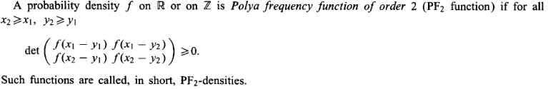

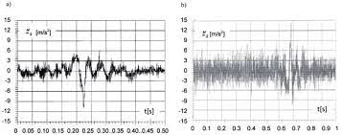

**Figure 2: Example of PFn functions**

**2.7 Definition 6: (Linear Programming Problem)** Linear programs are problems that can be expressed in [standard form](https://en.wikipedia.org/wiki/Canonical_form) as :



Linear Programming Problems (LPP) are problems that are focused with determining the best value for a given linear function. The ideal value might be either the greatest or the least. The supplied linear function is regarded as an objective function in this context. Linear programming is a technique for optimizing a linear objective function under linear equality and linear inequality constraints. Its viable region is a convex polytope, which is a set defined as the intersection of an infinite number of half spaces, each specified by a linear inequality. Its goal function is a polyhedral real-valued affine (linear) function. A linear programming algorithm locates a place on the polytopes where this function has the least (or greatest) value (if such a point exists.).

The aim of actuarial mathematics is to apply mathematical and statistical techniques to assess and manage risk in various financial and insurance contexts. Actuarial mathematics involves analysing data, modelling risk, and making predictions to help individuals and organizations make informed decisions regarding risk management and financial planning. Actuarial mathematics helps assess and quantify various types of risks, such as mortality risk, morbidity risk, longevity risk, and financial risk. By analyzing historical data and using statistical models, actuaries can estimate the likelihood and impact of different risks.

Actuaries play a crucial role in setting insurance premiums and determining appropriate reserves. They use mathematical models to assess the expected claims and expenses associated with insurance policies, ensuring that premiums adequately cover the potential losses and expenses. Actuaries assist in identifying and managing risks by developing risk mitigation strategies, such as reinsurance programs, hedging techniques, and capital management strategies. They use mathematical models, such as stochastic modeling and scenario analysis, to evaluate the impact of different risk management strategies. Actuaries ensure compliance with regulatory requirements by performing financial and risk assessments that meet regulatory standards. They provide expertise in areas such as solvency requirements, reserve adequacy, and risk-based capital assessments. Overall, the aim of actuarial mathematics is to help individuals, businesses, and insurance companies make informed decisions in the face of uncertainty, by applying mathematical and statistical techniques to understand and manage risk effectively. In the context of risk management, the terms "retention function" and "compensation function" refer to two different approaches in handling risk.

The research until now has been focusing around predicting fixed linear model with respect to a big reinsurance farm. However, models heavily rely on historical data to estimate probabilities, correlations, and other parameters. Insufficient or low-quality data can introduce biases and inaccuracies in the model outputs. Additionally, models may struggle to account for emerging or unforeseen risks due to the lack of relevant historical data. Additionally, reinsurance and risk management involve dealing with uncertainties and volatile market conditions. Models may struggle to accurately capture and quantify these uncertainties, leading to potential inaccuracies in risk assessments and decision-making. Mathematical models typically assume rational and consistent behaviour from market participants. However, human behaviour can be influenced by emotions, biases, and other psychological factors, which may not be fully accounted for in the models. This can lead to discrepancies between model predictions and actual outcomes.

As reinsurance and risk management become more sophisticated, the underlying models can become complex, involving numerous assumptions, parameters, and calculations. This complexity introduces the risk of model errors, model degeneracy, and model misuse, which can undermine the reliability of model outputs. Mathematical models used in reinsurance and risk management must comply with regulatory requirements and legal frameworks. However, these regulations and laws can evolve over time, and models may struggle to adapt to changing requirements and constraints. It is crucial to recognize these limitations and exercise caution when relying solely on mathematical models for reinsurance and risk management. Note that models should be used as tools to inform decision-making, but they should not be treated as easy feed for machine learning alone. Expert judgment, qualitative analysis, and a holistic understanding of the business context should complement the insights provided by exact mathematical models. We emphasize that depending on the structure of the retention and compensation function, efficiency of reinsurance policies increases if the claims are divided among multiple farms. We examine the structure of local retention and compensation functions so that the global structure is approximately retained through superposition. In this context we examine densities of the PF2 type (Poly’s frequency function of order 2) to model the overall risk involved in the reinsurance contract and the consequent reinsurer’s efficiency. The assumption that the retention functions and compensation functions are monotonously increasing is Valid as incremental claims suppose not only the share increase of an insurance company, but also of its reinsurers in covering the claim amount. We show that this aspect forces additional structure on the retention functions and compensation functions that helps us determine the reinsurer’s efficiency and the type of distributions that allows compensation functions to be treated as a stochastic objective function.

CHAPTER 3

RESEARCH METHODOLOGY

Mathematical structures of compensation and retention functions play a crucial role in setting reinsurance models and determining appropriate returns. Overall, the aim of actuarial mathematics is to help individuals, businesses, and insurance companies make informed decisions in the face of uncertainty, by applying mathematical and statistical techniques to understand and manage risk effectively. In the context of risk management, the terms "retention function" and "compensation function" refer to two different approaches in handling risks. The thesis shows that the risks better be divided into small parts for a risk insurance farm to increase reinsurer efficiency under the practical condition of monotonicity of retention and compensation. Especially, given the constituent risks of PF2 type (Poly’a frequency function of order 2), the overall risk involved in the reinsurance contract is also PF2 type, and less than (or equal to) the sum of individual risks involved. Consequently, the reinsurer efficiency increases. We use the property of monotonicity, and positive definiteness to bring out the locally linear structure of certain retention and compensation functions. The structure of overall retention and compensation functions follow the respective local structures so that a locally linear risk reduction (and, return maximization) problem can be formulated for constructing portfolios in the reinsurance market.

Mathematical methods play a crucial role in risk modelling in reinsurance. These methods help reinsurance companies assess and quantify various types of risks, including underwriting risk, investment risk, and catastrophic risk. Here are some mathematical methods commonly used in risk modelling for reinsurance:

**3.1 Stochastic Modelling and Probability Theory:** Probability theory forms the foundation of risk modelling. It involves calculating the likelihood of different outcomes and their associated probabilities. Techniques such as probability distributions, conditional probability, and Bayes' theorem are used to assess the probability of various events, including insurance claims. Stochastic models incorporate randomness and uncertainty into risk assessments. Monte Carlo simulation, for example, is a widely used stochastic method in which random variables are sampled repeatedly to model various scenarios. Stochastic modelling helps estimate the distribution of potential losses and identify extreme events. As we move on deeper into this document, we will mostly use this particular variety of mathematical modelling.

**3.1.1 Actuarial Models:** Actuarial models are used to estimate future claims and liabilities based on historical data. Techniques such as the chain ladder method and loss development triangles are employed to project loss development patterns and calculate reserve requirements.

**3.1.2 Value at Risk (VaR):** VaR is a statistical measure used to estimate the maximum loss an insurer or reinsurer may incur within a specified confidence interval over a given time horizon. VaR is calculated using statistical techniques such as the historical simulation method or parametric models. Value at Risk (VaR) is a widely used risk assessment tool in reinsurance and insurance industries. It quantifies the maximum potential loss a portfolio may experience over a specified time horizon, at a specified confidence level. In reinsurance, VaR helps assess and manage the financial impact of extreme events and tail risks. Here's how VaR is applied in risk assessment for reinsurance:

VaR is defined as the maximum potential loss at a specific confidence level (e.g., 99% or 95%) over a given time period (e.g., one year). It represents the dollar amount that is not expected to be exceeded with the specified probability.

**3.1.3 Data Preparation:** To calculate VaR, reinsurance companies gather historical data on losses or claims for the specific portfolio or line of business under consideration. This data should cover a sufficiently long period to capture a range of loss scenarios.

**3.1.4 Portfolio Identification:** Reinsurers identify the specific portfolio or group of policies they want to assess. VaR can be calculated for individual policies, lines of business, or the entire reinsurance portfolio, depending on the level of granularity desired.

**3.1.5 Time Horizon Selection:** The choice of time horizon is important in VaR calculation. It should reflect the relevant risk assessment period for the portfolio. Common time horizons are one year or shorter.

**3.2 Confidence Level Determination:**

The confidence level represents the probability that the VaR estimate will not be exceeded. A higher confidence level (e.g., 99%) corresponds to a more conservative estimate. Reinsurers typically select a confidence level based on their risk tolerance and regulatory requirements. There are various methods to estimate VaR in reinsurance, including historical VaR, parametric VaR, and Monte Carlo VaR.

Historical VaR: This method uses historical loss data to estimate VaR. It ranks historical losses and identifies the loss corresponding to the selected confidence level.

Parametric VaR: Parametric VaR assumes a specific probability distribution for the data (e.g., normal distribution) and uses statistical parameters to estimate VaR.

Monte Carlo VaR: Monte Carlo simulation involves generating thousands of scenarios based on historical data and analysing the resulting distribution of potential losses to estimate VaR.

**3.2.1 Tail VaR:** In reinsurance, tail VaR is often of particular interest because it focuses on extreme losses in the tail of the distribution. Tail VaR provides insight into the risk of catastrophic events.

**3.2.2 Interpretation and Decision-Making:** Once VaR is calculated, reinsurers can interpret the results in the context of their risk management strategy. If the estimated VaR exceeds acceptable risk thresholds, reinsurers may consider risk mitigation strategies, such as portfolio diversification, reinsurance of excess risk, or capital allocation adjustments.

**3.2.3 Validation and Monitoring:** Continuous validation and monitoring of VaR models and assumptions are essential. Reinsurers should assess the accuracy of VaR estimates and make adjustments as needed based on actual experience and changes in the portfolio.

VaR is a valuable tool in reinsurance risk assessment, but it should be used in conjunction with other risk management techniques and considerations, such as stress testing, scenario analysis, and diversification. Reinsurers must also recognize the limitations of VaR, especially in the context of extreme and tail risks, and supplement it with additional risk assessment tools for a comprehensive view of their risk exposure.

**3.3 Extreme Value Theory (EVT):**

EVT is used to model and analyse extreme events or tail risks, such as catastrophic losses. It focuses on the tail of the probability distribution and employs methods like the generalized Pareto distribution (GPD) to estimate tail probabilities. Extreme Value Theory (EVT) is a branch of statistics and probability theory that focuses on the modelling and analysis of extreme events or values in a data set. EVT is particularly valuable in risk assessment and management, as it provides a framework for understanding and quantifying tail risks, which are the rare but potentially catastrophic events that can have a significant impact on financial portfolios, insurance claims, and other areas. Here are the key components and concepts of Extreme Value Theory:

**3.3.1 Tail Distributions:** EVT deals with the tails of probability distributions. These tails represent the extreme values of a distribution, which are often of interest in risk analysis.

**3.3.2 Block Maxima and Peak-Over-Threshold:** EVT commonly considers two approaches to analysing extreme events: block maxima and peak-over-threshold. Block Maxima: In this approach, data is divided into non-overlapping blocks, and the maximum value within each block is analysed. This method is suitable for data with natural grouping, such as annual maximum river flows. Peak-Over-Threshold: This approach focuses on values exceeding a predefined threshold. It models the distribution of exceedances over the threshold, making it suitable for more irregularly spaced data.

**3.3.3 Generalized Extreme Value (GEV) Distribution:** The GEV distribution is a fundamental distribution in EVT. It describes the limiting distribution of extremes and can be used to model the tail behaviour of various data types. The GEV distribution has three parameters: location (μ), scale (σ), and shape (ξ). These parameters determine the location of the distribution, its scale relative to the location, and the shape of the tail (heavy or light). The Hill estimator is used to estimate the shape parameter (ξ) of the GEV distribution. It quantifies the tail heaviness and helps identify whether the distribution has a finite upper bound or is unbounded. EVT provides a way to estimate return levels, which represent the values that are expected to be exceeded with a certain probability within a specified time frame. Return levels are essential for risk assessment, particularly in insurance and finance.

EVT can be applied to various fields, including finance, insurance, hydrology, and environmental science. It helps model and assess extreme events such as financial market crashes, natural disasters, and extreme climate events. EVT is a valuable tool for quantifying tail risk, which is the risk associated with extreme events. It allows organizations to estimate the likelihood and potential impact of rare but severe events on their portfolios or operations.

**3.3.4 Limitations:** EVT assumes stationarity (i.e., the underlying distribution remains the same over time), which may not hold in all cases. Additionally, EVT is most effective when analysing data with a sufficient number of extreme observations.

Extreme Value Theory is an important tool for understanding and managing risks associated with extreme events. It provides a robust framework for estimating tail probabilities, modelling rare events, and making informed decisions in various fields where extreme events can have substantial consequences.

**3.5 Copula Models:**

Copula models are used to capture the dependence structure between different risk factors or variables, especially in multivariate risk modelling. Copulas help assess how risks are correlated and can be crucial in modelling portfolio risk. Copula models can guide risk mitigation strategies. Reinsurers can identify high-dependence scenarios and develop risk management measures, such as diversification, reinsurance, or capital allocation adjustments. Validation techniques include goodness-of-fit tests, back-testing, and sensitivity analysis. Copula models can inform reinsurance pricing decisions by considering the joint distribution of risks. They help reinsurers set appropriate premium rates and retention levels based on the dependence structure between ceding insurer and reinsurer risks. However, the parameters of the selected copula model need to be estimated from historical data. This involves estimating the copula parameters that describe the shape and strength of the dependence structure. Maximum likelihood estimation (MLE) is commonly used to estimate copula parameters. Bayesian methods can also be employed for parameter estimation. The parameters of the selected copula model need to be estimated from historical data. This involves estimating the copula parameters that describe the shape and strength of the dependence structure. Maximum likelihood estimation (MLE) is commonly used to estimate copula parameters. Bayesian methods can also be employed for parameter estimation.

Copula models can be used for stress testing reinsurance portfolios. By simulating extreme scenarios using copula-based joint distributions, reinsurers can assess the impact of simultaneous extreme events on their portfolios. They allow reinsurers to assess the risk of portfolios of insurance or reinsurance contracts. By modelling the dependence between contracts, reinsurers can estimate portfolio risk measures, such as value at risk (VaR) and conditional tail expectation (CTE). The models are particularly useful for capturing tail dependence, which represents the likelihood of extreme events occurring jointly across different risks. Tail dependence is crucial in reinsurance, where catastrophic events can impact multiple contracts.

Copula models provide a versatile framework for modelling and managing reinsurance risks, especially in situations where traditional methods may not adequately capture complex dependencies. However, it's important to select appropriate copula families and validate models rigorously to ensure they reflect the true risk dynamics in the reinsurance portfolio.

**3.6 Time Series Analysis:**

Time series analysis is employed to model and forecast financial variables, including investment returns and interest rates. Methods like autoregressive integrated moving average (ARIMA) models and GARCH models help capture time-dependent patterns and volatility. Time series analysis is a valuable statistical method used in reinsurance for risk assessment and modelling. It involves the study of data collected or observed over a series of equally spaced time intervals. Time series data is common in reinsurance, where historical records of claims, premiums, and other financial and operational metrics are available. Here's how time series analysis can be applied to risk assessment in reinsurance:

**3.7 Claim Frequency and Severity Modelling:** Time series analysis can help reinsurance companies model the historical patterns of claim frequency (the number of claims) and claim severity (the size of individual claims). By analysing historical data, reinsurers can identify trends, seasonality, and potential outliers.

**3.7.1 Trend Analysis:** Reinsurers use time series analysis to identify and quantify long-term trends in claims or premium volumes. Understanding trends is crucial for projecting future risks and setting appropriate reserves and premiums.

**3.7.2 Seasonal Patterns:** Many reinsurance portfolios exhibit seasonal variations in claims or premiums. Time series analysis can capture and model these seasonal patterns, allowing reinsurers to account for recurring risk fluctuations.

**3.7.3 Cyclicality Assessment:** In addition to short-term seasonality, time series analysis can help identify cyclicality in reinsurance data. Understanding cyclic patterns can inform risk management and capital allocation decisions.

**3.7.4 Volatility and Variability:** Time series analysis allows reinsurers to assess the volatility and variability of risk metrics over time. Volatility measures, such as standard deviation and variance, are essential for quantifying risk.

**3.7.5 Reserving and Loss Projections:** Reinsurers use time series models to estimate future claims and loss reserves. Methods like Bonesetter-Ferguson, chain ladder, and loss development triangles rely on time series data to project future liabilities.

**3.7.6 Stress Testing:** Time series analysis is instrumental in stress testing reinsurance portfolios. By simulating extreme scenarios and perturbing time series data, reinsurers can assess the potential impact of severe events on their financial positions.

**3.7.7 Premium Rate Setting:** Reinsurance premium rates often depend on historical data and expected future claims. Time series analysis helps estimate the appropriate premium rates based on past experience.

**3.7.8 Loss Ratio Analysis:** Time series analysis is used to monitor loss ratios over time. High loss ratios may indicate underwriting issues or adverse claims trends, prompting risk management actions.

**3.7.9 Model Validation:** Time series models used in reinsurance must be validated to ensure their accuracy. Validation involves comparing model projections to actual data and assessing the model's predictive performance.

**3.7.10 Claim Reserving Techniques:** Time series analysis plays a vital role in estimating outstanding claims reserves, which are essential for financial reporting and solvency assessment. Techniques like the chain ladder method and *Bonesetter-Ferguson method* rely on historical claims development patterns.

**3.7.11 Regression Analysis:** Time series data can be used in regression analysis to understand the relationships between risk factors and claims experience. This helps identify variables that significantly impact risk.

**3.7.12 Portfolio Analysis:** Reinsurers can perform time series analysis at the portfolio level to assess the overall performance and risk characteristics of their reinsurance business. Time series analysis provides reinsurers with a robust framework for understanding the historical behaviour of risks and making informed decisions about future risk management strategies. When combined with other statistical and modelling techniques, it enhances risk assessment and helps ensure the financial stability of reinsurance portfolios.

**3.8 Bayesian Methods:**

Bayesian methods combine prior information and data to update probabilistic beliefs about risks. Bayesian networks and Bayesian regression models are used to incorporate expert knowledge and assess risks in a Bayesian framework. Bayesian methods offer a powerful and flexible approach to risk assessment in reinsurance by combining prior information with observed data to update probabilistic beliefs about risks. Bayesian methods are particularly valuable when dealing with limited data or when incorporating expert knowledge into the risk assessment process. Here's how Bayesian methods can be applied to risk assessment in reinsurance:

Bayesian Probability Framework: Bayesian probability theory is based on Bayes' theorem, which describes how to update beliefs about an event as new evidence or data becomes available. In the context of risk assessment, it allows reinsurance professionals to combine prior beliefs (prior probabilities) with new data (likelihood) to obtain updated beliefs (posterior probabilities). In Bayesian risk assessment, prior beliefs represent initial subjective probabilities or knowledge about a risk before any data is considered. These beliefs can be based on historical data, expert judgment, or other sources of information.

In reinsurance, prior beliefs may include assumptions about the frequency and severity of insurance claims, portfolio characteristics, or risk factors. The likelihood function quantifies the probability of observing the data given a particular set of parameters or assumptions. It represents the likelihood of the observed data under different scenarios. In reinsurance, the likelihood function can describe the probability distribution of historical claims data, taking into account various modelling assumptions and parameter values.

**3.8.1 Posterior Probability:** The posterior probability is the updated belief or probability after considering the observed data. It combines the prior beliefs and likelihood to provide a more informed estimate of risk. In reinsurance, the posterior probability can represent the updated risk assessment, incorporating both prior knowledge and new data.

**3.8.2 Bayesian Modelling:** Bayesian methods can be applied to various aspects of reinsurance risk assessment, including modelling loss distributions, estimating premium rates, and evaluating risk transfer options. Bayesian modelling allows for the incorporation of uncertainty and variability in risk assessments, making it well-suited for complex and dynamic reinsurance portfolios.

**3.8.3 Expert Elicitation:** Bayesian methods are useful for eliciting expert opinions and incorporating them into risk assessments. Experts can provide valuable insights into risk factors, correlations, and extreme event scenarios. In reinsurance, expert elicitation can help refine risk models and assess tail risks associated with catastrophic events.

**3.8.4 Sensitivity Analysis:** Bayesian methods facilitate sensitivity analysis by allowing reinsurance professionals to explore the impact of different assumptions and parameter values on the posterior probabilities.

Sensitivity analysis helps identify critical risk factors and assess the robustness of risk assessments.

**3.8.5 Sequential Updating:** Bayesian methods support sequential updating of risk assessments as new data becomes available over time. This feature is particularly valuable in reinsurance, where portfolio characteristics may change.

**3.8.6 Model Comparison:** Bayesian methods enable model comparison by assessing the fit of different models to the observed data. Reinsurance professionals can choose the most appropriate model based on Bayesian model selection criteria.

**3.8.7 Uncertainty Quantification:** Bayesian methods provide a framework for quantifying uncertainty in risk assessments. Bayesian credible intervals can be used to quantify the range of possible outcomes with a specified level of confidence

**3.8.8 Machine Learning and Artificial Intelligence (AI):** Machine learning techniques, including neural networks, decision trees, and random forests, are increasingly used in risk modelling for pattern recognition, predictive modelling, and fraud detection.

**3.8.9 Spatial Analysis:** Spatial analysis is crucial for modelling geographic risks, such as natural catastrophes. Geographic information systems (GIS) and spatial statistics help assess the likelihood and impact of events like hurricanes, earthquakes, and floods.

**3.9 Non-parametric Statistics:**

Non-parametric methods, such as kernel density estimation and bootstrapping, are employed when the underlying probability distribution of data is not known or when data is sparse. Non-parametric statistics offer a flexible approach to risk modelling in reinsurance when the underlying probability distribution of data is unknown or when data does not meet the assumptions of parametric models.

**3.9.1 Kernel Density Estimation (KDE):** KDE is a technique used to estimate the probability density function (PDF) of a random variable based on observed data points. It is particularly useful when the shape of the distribution is not known in advance.

In reinsurance, KDE can be used to estimate the distribution of insurance claims or losses. It provides a smooth, continuous estimate of the distribution, making it valuable for risk assessment and scenario analysis.

**3.9.2 Empirical Cumulative Distribution Function (ECDF):** The ECDF is a non-parametric way to visualize the cumulative distribution of data. It represents the proportion of data points that are less than or equal to a given value. Reinsurers can use the ECDF to assess the historical distribution of losses or claims, making it easier to understand the tail risk and potential extreme events.

**3.9.3 Bootstrapping:** Bootstrapping is a resampling technique used to estimate the sampling distribution of a statistic by repeatedly sampling from the observed data with replacement.

In reinsurance, bootstrapping can be used to generate thousands of simulated scenarios, allowing reinsurers to estimate risk measures such as value at risk (VaR) and conditional tail expectation (CTE) without assuming a specific parametric distribution.

**3.9.4 Quantile Regression:** Quantile regression is a non-parametric regression technique used to estimate conditional quantiles of a response variable. It provides insights into how different factors affect specific quantiles of a distribution.

In reinsurance, quantile regression can be applied to assess the relationship between risk factors (e.g., policy attributes, geographic regions) and the distribution of claims or losses at various quantiles.

**3.9.5 Rank-Order Statistics:** Rank-order statistics, such as order statistics and rank-sum tests, are used to analyse the relative positions of data points within a dataset. Reinsurers can use rank-order statistics to assess the significance of extreme events or to identify outliers that may indicate unusual or catastrophic losses.

**3.9.6 Kernel Smoothing for Conditional Tail Probabilities:** Kernel smoothing methods can be applied to estimate conditional tail probabilities, which are crucial for assessing tail risk in reinsurance portfolios. This involves using a kernel function to smooth the tail of the empirical distribution function.

**3.9.7 Local Regression (LOESS):** LOESS is a non-parametric regression technique that uses local weighted regression to estimate a smoothed curve through data points.

In reinsurance, LOESS can be applied to analyse the relationship between variables and the distribution of losses, allowing for non-linear patterns to be captured.

Non-parametric statistical methods are valuable in reinsurance because they do not make strong assumptions about the underlying data distribution. This flexibility is particularly useful when dealing with complex, real-world data that may not conform to standard parametric distributions. By leveraging non-parametric statistics, reinsurers can gain a more accurate understanding of the distribution of risks and improve their risk assessment and management processes.

**3.10 Queuing Theory:**

Queuing theory is used to model the flow of claims in insurance and reinsurance processes. It helps assess service times, queue lengths, and waiting times in claims processing. Queuing theory is a mathematical framework that can be applied to risk measurement in reinsurance, particularly in scenarios involving the flow of claims and the allocation of resources. While queuing theory is more commonly associated with operations research and the study of waiting lines, it can be adapted to assess various aspects of risk in reinsurance.

**3.10.1 Claims Processing Time:** Queuing theory can help reinsurance companies model and analyse the time it takes to process insurance claims. By understanding the distribution of processing times and potential bottlenecks in claims handling, reinsurers can estimate the risk of delays in claims settlement.

**3.10.2 Resource Allocation:** Reinsurance companies often need to allocate resources efficiently to manage claims and underwriting activities. Queuing models can optimize resource allocation decisions by considering factors such as staffing levels, workload, and service times. Efficient resource allocation can reduce operational risks and improve customer satisfaction.

**3.10.3 Service Level Agreements:** Queuing theory can be used to assess compliance with service level agreements (SLAs) in claims processing. By modelling the queuing system and analysing performance metrics such as waiting times and queue lengths, reinsurers can measure the risk of SLA violations and take preventive actions.

**3.10.4 Risk of Claims Backlog:** Reinsurers can use queuing models to estimate the risk of claims backlog, which occurs when the number of incoming claims exceeds processing capacity. By quantifying the probability of backlog occurrence, reinsurers can plan for contingencies and resource adjustments.

**3.10.5 Policyholder Experience:** Queuing theory can be applied to measure the impact of claims processing delays on policyholder experience and satisfaction. Delays in claims settlement can lead to dissatisfaction and reputational risks for insurers and reinsurers.

**3.10.6 Stress Testing:** Queuing models can be used for stress testing reinsurance operations. By simulating extreme scenarios of high claims volume or prolonged processing times, reinsurers can assess the resilience of their operations and identify vulnerabilities under stress conditions.

**3.10.7 Resilience Planning:** Queuing theory helps reinsurers develop resilience plans that account for operational risks. By identifying critical points in the claims processing workflow, reinsurers can implement measures to mitigate risks associated with interruptions or system failures.

**3.10.8 Queue Length Dynamics:** Analysing the dynamics of queue lengths in claims processing can reveal insights into risk patterns. Queuing models can estimate the probability of queue overflow, which occurs when the queue exceeds its capacity, leading to potential service disruptions.

**3.10.9 Capacity Planning:** Queuing theory guides capacity planning decisions. Reinsurers can assess whether existing resources are sufficient to meet demand or if additional capacity is needed to manage risks associated with fluctuations in claims volume.

**3.11 Operational Risk Assessment:** Queuing theory contributes to operational risk assessment in reinsurance. By modelling the claims processing workflow as a queuing system, reinsurers can identify vulnerabilities and develop risk mitigation strategies.

While queuing theory provides valuable insights into operational risks in reinsurance, it should be complemented by other risk measurement methods, such as statistical analysis, actuarial modelling, and stress testing, to provide a comprehensive view of risk across different dimensions of the reinsurance business.

Effective risk modelling in reinsurance often involves a combination of these mathematical methods, tailored to the specific types of risk being assessed and the available data. Reinsurance companies continuously refine their risk models and leverage advances in mathematics and data science to improve their risk assessment capabilities and support informed decision-making.

The thesis, also, proposes an LPP for constructing efficient portfolios from reinsurance efficiency function as obtained from data in reinsurance markets. The Pareto solutions aim to determine the balanced equilibrium between expected retention and the compensation below a specific threshold. Stochastic parameters in the risk and retention is handled using the structure of retention functions that can be suitably linearized. The proposed scheme emphasizes the algorithmic methods available in LPP to numerically calculate the structure of efficient portfolios for given reinsurance contracts by parts. The Pareto solutions arise from the superposition individual LPP solutions. Risk-LPP can be solved numerically by realizing the two-step method available for algorithmically solving group constraints, The Pareto solution fronts, defined by the convex-type equality ~x∗(α) = α~x∗1 + (1 − α)~x where α ∈ [0, 1] are central to risk reduction and compensation augmentation. Choosing a numerical value of α, the specific structures are derived and plotted for the desired reinsurance portfolio. Note that when α = 1, the effective portfolio of reinsurance company, that corresponds to the maximum expected value of return, is characterized, and in the case where α = 0, the structure of the effective reinsurance portfolio, that corresponds to the minimum risk, is realized. We provide a multi-objective algorithm for Pareto solutions in retention and compensation in reinsurance which can introduce the deep learning methods to decision-making in reinsurance.

The retention function involves retaining or assuming a certain portion of the risk within an organization or individual's own resources. Instead of transferring the risk to an external party, such as an insurer or reinsurer, the entity retains the financial responsibility for potential losses. The retention function is commonly used when the cost of transferring the risk is deemed higher than the potential loss itself. It requires the entity to have sufficient financial resources to cover potential losses. The compensation function, on the other hand, focuses on transferring the risk to an external party, typically through insurance or reinsurance contracts. By paying premiums or fees, the entity shifts the financial responsibility for potential losses to the insurer or reinsurer. The compensation function provides protection against unexpected losses and helps mitigate the financial impact of those losses. It's important to note that the specific mathematical structures of compensation and retention functions in reinsurance can vary significantly based on the terms and conditions outlined in the reinsurance contract. The models of these functions outlined in the thesis provide a general understanding of the mathematical representations commonly applicable in reinsurance, but actuarial details may differ based on the specific agreement between the insurer and reinsurer. Especially, the behaviour of the PF2 function can be quite complex and depends on the specific values and relationships for a large insurance farm. Therefore, it is necessary to analyse the PF2 function for determining reinsurer efficiency on a case-by-case basis to understand its monotonicity properties accurately.

Both retention and compensation functions have their advantages and considerations. Retaining risk allows for more control over the risk management process and may be cost-effective for smaller or less severe risks. However, it also exposes the entity to the full financial consequences of potential losses. On the other hand, transferring risk through compensation provides financial protection and can help mitigate the impact of large or catastrophic losses. However, it involves costs in the form of insurance premiums or reinsurance fees. The decision to use either the retention function or compensation function depends on various factors, including the entity's risk appetite, financial strength, the nature of the risk, and the cost-benefit analysis of retaining versus transferring the risk. Risk management professionals and actuaries often analyse these factors to determine the most appropriate risk management strategy for a given situation.

Insurers can use linear programming to optimize their risk retention levels. By formulating the problem as a linear programming model, insurers can set constraints on the amount of risk they retain for different types of policies or coverage areas. The model can consider factors such as the insurer's capital position, risk tolerance, and the potential cost of reinsurance. The objective is to find the optimal balance between retaining risk and transferring it through reinsurance to minimize overall risk exposure. Linear programming can assist insurers in selecting the most appropriate reinsurance contracts or reinsurers. By formulating the problem as a linear programming model, insurers can set constraints and objectives based on factors such as pricing, coverage limits, financial stability of reinsurers, and contractual terms. The model can help determine the optimal combination of reinsurance contracts that minimizes the potential for losses while maximizing the benefits of risk transfer. Overall, linear programming provides a mathematical framework to optimize risk reduction strategies in reinsurance. By formulating the problem as a linear programming model, insurers can make data-driven decisions to allocate risk, select reinsurance contracts, and optimize capital allocation to minimize potential losses and enhance their financial stability. Intelligent estimation of retention function and compensation function is difficult from organizational and personal data of insurance details without imposing certain mathematical structures on the objective. Both of retention function and compensation function can be risk minimization objectives depending on the context; but we show that one forces certain structures on the other. Further, these mathematical structures ensure that retention function and compensation functions can be nonlinear while the risk can be reduced locally, especially if the risks do not associate global calamities and catastrophe where local linearization may turn out to be invalid due to the limitation on tangent spaces. The proposed framework can be used to estimate company specific retention and compensation policies over a period of claim repayment. However, the retention function often depends on a few other conditions like pandemic, man-made disasters which we do not include. However, the retention function often depends on a few other conditions like pandemic, man-made disasters which we do not include. However, the retention function often depends on several other conditions like pandemic, man-made disasters which we do not include.

CHAPTER 4

ANALYSIS

In this section we bring out the mathematical structure of associated compensation and retention function and the PF2 nature of local risks to be additive.

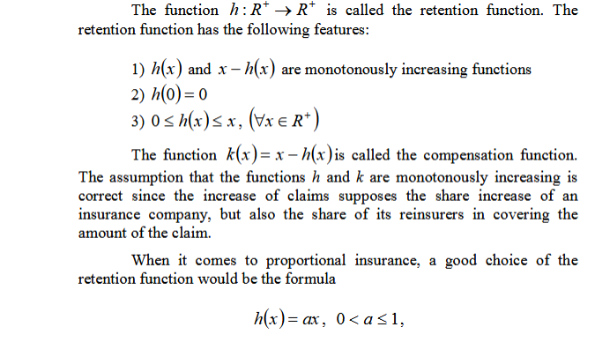 (5.1)

This is the structure of local retention and compensation functions. As *X (claim x) i*s a random variable we want to know the distribution type that governs the risks so as to confirm that the global structure of risk is additive with respect to the local structures. This also confirms that the local structure of retention and compensation for each claim variable X carries over to the overall retention and compensation functions. The answer is PF2 density functions with guaranteed positive definiteness which confirm the monotonicity of retention and compensation. We exploit the following results from real analysis and probability theory to show that if each of the claims in random variable *X* is PF2 then the total risk is also PF2.

**Proposition 1:**

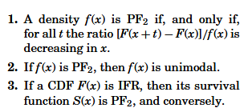

The following theorem is due to **B. Efron , and others later .**

**4.1:**

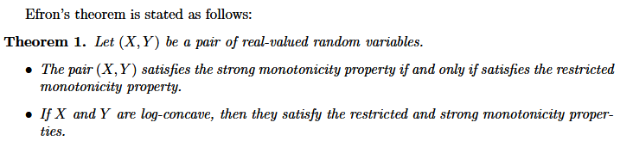

We impose the log-concavity assumption on the compensation functions from theorem 1. The following result from statistics and probability theory handles the conditional expectation for modelling risks .

**4.2:**

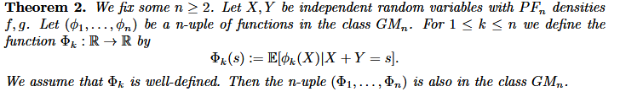(5.2)

The following theorem can be found in advanced texts on linear algebra **[27].**

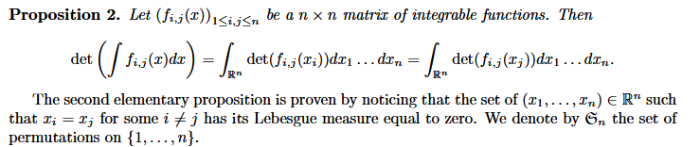

Now we come to the first main result for risk characterization in reinsurance. The result is given for *Xi,* *i=2*, but by method of induction, can be extended to finite number of risks. We provide an outline of the proof that PF2 risk densities are additive.

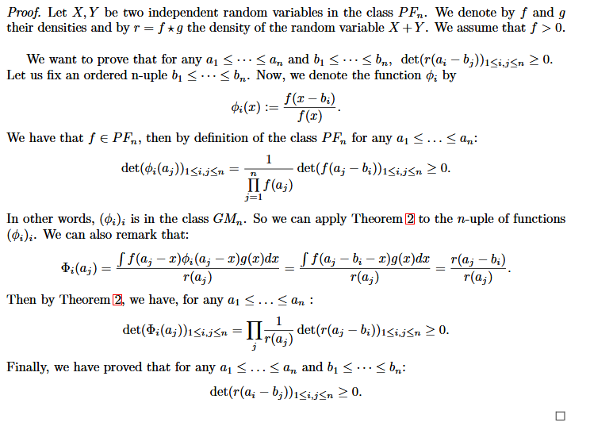

Using a more elaborate version of Efron’s theorem, with a stronger assumption on the monotonicity of φ on each claim variable we can derive a more powerful conclusion. We state the two different.

Mathematical forms. The forms differ in their choice of the continuous random variable or a integer valued mass function.

**4.3:**

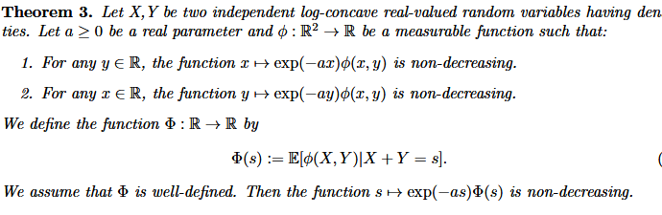

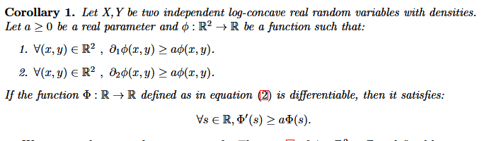

The following theorem is due to **B. Efron,** which allows us to fix the type of distributions that can model the risks associated with the network of insurance and reinsurance described in **Fig. 1.** The allowed probability distributions are listed after we the statement of the theorem. The proof for individual distributions can be found in advanced text of measure theory.

**4.4:**

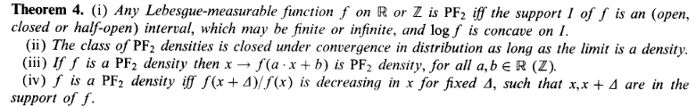

**Allowed probability distributions:**

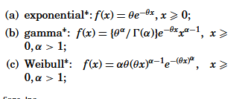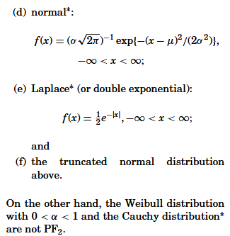

These are the allowable distributions among the prominent ones to model the individual risks associated with individual claims *Xi*  to redistribute risk in such a way that the total risk is still PF2.

The Laplace distribution, also known as the double exponential distribution, is a probability distribution frequently used in risk modelling and statistical analysis. It has several characteristics that make it suitable for various aspects of risk assessment in reinsurance and insurance. Here's how the Laplace distribution can be applied for risk modelling:

**4.5 Modelling Asymmetric Risk:**

The Laplace distribution is well-suited for modelling asymmetric risk, where the probability of extreme events in one direction (e.g., large losses) is different from the other direction (e.g., large gains or profits). This is often the case in insurance and reinsurance, where losses are more likely than gains.

Fat Tails and Outliers:

The Laplace distribution has thicker tails than the normal distribution, which makes it capable of capturing fat-tailed or heavy-tailed distributions. This is crucial in risk modelling, as it helps account for the possibility of extreme events and outliers that can significantly impact a reinsurance portfolio.

Stress Testing:

The Laplace distribution can be used in stress testing scenarios to assess the impact of extreme events on a reinsurance portfolio. By simulating Laplace-distributed losses under severe conditions, reinsurers can evaluate their resilience to tail risks.

Value at Risk (VaR):

The Laplace distribution is used to estimate Value at Risk, a key risk measure in financial and insurance risk management. VaR quantifies the potential loss a portfolio may incur at a specific confidence level. The Laplace distribution helps estimate VaR when dealing with non-normally distributed data.

Loss Severity Modelling:

In reinsurance, the Laplace distribution can be used to model the distribution of loss severities (claim amounts). It allows for the modelling of heavy-tailed loss distributions, which are common in insurance.

Parameter Estimation:

Accurate parameter estimation is essential when using the Laplace distribution for risk modelling. Methods like maximum likelihood estimation (MLE) or Bayesian estimation are commonly used to estimate the distribution's parameters.

Skewed Distributions: The Laplace distribution is naturally skewed and can capture the asymmetry often observed in risk data. This is valuable for modelling claims and premiums that exhibit skewness.

Loss Reserving:

The Laplace distribution can be used in claims reserving to estimate outstanding liabilities for claims that have been reported but not yet settled. It helps quantify the risk associated with future payments.

Premium Rate Setting:

The Laplace distribution can be used to model the distribution of potential losses. This information is critical for setting appropriate premium rates to cover expected losses.

Model Validation:

As with any statistical distribution, it's essential to validate the fit of the Laplace distribution to the observed data to ensure it accurately represents the underlying risk. Goodness-of-fit tests and visual inspections can be used for validation.

The Laplace distribution provides reinsurance professionals with a versatile tool for modelling and assessing risks with heavy tails and asymmetrical characteristics. It allows for a more realistic representation of risk and its potential impact on a reinsurance portfolio, particularly when dealing with non-normally distributed data. The Laplace distribution, also known as the double exponential distribution, is a probability distribution frequently used in risk modelling and statistical analysis. It has several characteristics that make it suitable for various aspects of risk assessment in reinsurance and insurance. Here's how the Laplace distribution can be applied for risk modelling:

**4.6 Modelling Asymmetric Risk:**

The Laplace distribution is well-suited for modelling asymmetric risk, where the probability of extreme events in one direction (e.g., large losses) is different from the other direction (e.g., large gains or profits). This is often the case in insurance and reinsurance, where losses are more likely than gains.

**Fat Tails and Outliers:**

The Laplace distribution has thicker tails than the normal distribution, which makes it capable of capturing fat-tailed or heavy-tailed distributions. This is crucial in risk modelling, as it helps account for the possibility of extreme events and outliers that can significantly impact a reinsurance portfolio.

**Stress Testing:**

The Laplace distribution can be used in stress testing scenarios to assess the impact of extreme events on a reinsurance portfolio. By simulating Laplace-distributed losses under severe conditions, reinsurers can evaluate their resilience to tail risks.

**Value at Risk (VaR):**

The Laplace distribution is used to estimate Value at Risk, a key risk measure in financial and insurance risk management. VaR quantifies the potential loss a portfolio may incur at a specific confidence level. The Laplace distribution helps estimate VaR when dealing with non-normally distributed data.

**Loss Severity Modelling:**

In reinsurance, the Laplace distribution can be used to model the distribution of loss severities (claim amounts). It allows for the modelling of heavy-tailed loss distributions, which are common in insurance.

**Parameter Estimation:**

Accurate parameter estimation is essential when using the Laplace distribution for risk modelling. Methods like maximum likelihood estimation (MLE) or Bayesian estimation are commonly used to estimate the distribution's parameters.

**Skewed Distributions:**

The Laplace distribution is naturally skewed and can capture the asymmetry often observed in risk data. This is valuable for modelling claims and premiums that exhibit skewness.

**Loss Reserving:**

The Laplace distribution can be used in claims reserving to estimate outstanding liabilities for claims that have been reported but not yet settled. It helps quantify the risk associated with future payments.

**Premium Rate Setting:**

The Laplace distribution can be used to model the distribution of potential losses. This information is critical for setting appropriate premium rates to cover expected losses.

**Model Validation:**

As with any statistical distribution, it's essential to validate the fit of the Laplace distribution to the observed data to ensure it accurately represents the underlying risk. Goodness-of-fit tests and visual inspections can be used for validation.

The Laplace distribution provides reinsurance professionals with a versatile tool for modelling and assessing risks with heavy tails and asymmetrical characteristics. It allows for a more realistic representation of risk and its potential impact on a reinsurance portfolio, particularly when dealing with non-normally distributed data.

Exponential risk in reinsurance refers to the potential for losses to accumulate and grow rapidly, often driven by a compounding effect, as reinsurers provide coverage for primary insurers. This term is particularly relevant in the context of catastrophic events, such as natural disasters, where reinsurance plays a critical role in spreading and managing risk.

Here's how exponential risk in reinsurance can be understood:

**Primary Insurance:** Primary insurance companies, such as property and casualty insurers, offer policies to individuals and businesses to cover various risks. However, when there's a catastrophic event like a hurricane, earthquake, or major flood, the losses can be substantial and can quickly deplete the capital and reserves of primary insurers.

**Role of Reinsurance:** Reinsurance companies, or reinsurers, provide insurance to primary insurers. They essentially take on a portion of the risk in exchange for premiums. Reinsurance helps primary insurers mitigate the financial impact of large and unexpected losses.

**Exponential Risk:** Exponential risk arises when a reinsurance contract provides coverage to primary insurers for a catastrophic event. If multiple primary insurers have policies covering the same event, the losses can accumulate quickly. Reinsurers may find themselves exposed to significant losses that grow exponentially as they must pay out on multiple claims from various primary insurers.

**Cumulative Effect:** Exponential risk is often associated with events that impact a broad geographic area, such as a hurricane affecting multiple states or countries. When such an event occurs, the losses can accumulate across different insurers, and reinsurers may be faced with a cascading effect of claims that grow rapidly, possibly exceeding their capacity to pay.

**Risk Management:** Reinsurers use various risk management strategies to mitigate exponential risk. This may include diversifying their portfolio of reinsurance contracts, setting limits on the amount of coverage provided for specific events, and using computer models to assess their potential exposure to catastrophic events.

**Reinsurance Pricing:** The pricing of reinsurance contracts takes into account the potential for exponential risk. Reinsurers charge premiums based on the level of risk they are assuming and the likelihood of catastrophic events. Premiums for reinsurance may increase after major events to account for the increased risk awareness.

Exponential risk in reinsurance is a critical consideration in the insurance and reinsurance industry, as it underscores the need for careful risk assessment and management to ensure the financial stability of reinsurers in the face of large-scale disasters. It also highlights the interconnectedness of the insurance industry and the importance of spreading risk to avoid catastrophic financial losses.

"Gaussian risk" in reinsurance is a term that refers to a type of risk modelling and analysis often used in the reinsurance industry. It is based on the principles of the Gaussian distribution, also known as the normal distribution. This type of risk modelling assumes that risks are distributed according to a bell-shaped curve, with most outcomes clustered near the mean (average) and fewer outcomes at the tails (extremes) of the distribution. Here's how Gaussian risk modelling works in reinsurance:

**Risk Assessment:** When reinsurance companies assess the risk associated with providing coverage to primary insurers, they often use mathematical and statistical models to estimate potential losses. The Gaussian risk model assumes that the distribution of potential losses, such as those resulting from claims, follows a Gaussian or normal distribution.

**Normal Distribution:** In a normal distribution, the majority of losses or claims are expected to be near the mean, with fewer losses occurring as you move further away from the mean. This means that small to moderate losses are more likely, while very large losses are less likely, but still possible.

**Parameters:** Gaussian risk modelling requires defining parameters such as the mean (average) and standard deviation, which help describe the shape and characteristics of the normal distribution. The mean represents the expected loss, and the standard deviation measures the spread or variability of potential losses around the mean.

**Risk Management:** Reinsurance companies use Gaussian risk modelling to estimate the financial reserves they need to cover potential losses and determine the pricing of reinsurance contracts. They aim to ensure that they have sufficient capital to pay claims while maintaining financial stability.

**Limitations:** While Gaussian risk modelling is a widely used and valuable tool in the reinsurance industry, it has limitations. It assumes that losses are independent and identically distributed (i.i.d.), which may not always hold true for all types of risks, particularly in the case of rare and extreme events. Some catastrophic events, such as natural disasters or financial crises, may not conform to a normal distribution.

**Tail Risk:** Gaussian risk models may underestimate the likelihood of tail events or extreme losses. Reinsurance companies often use alternative risk modelling techniques, like heavy-tailed distributions or stress testing, to account for tail risk.

In summary, Gaussian risk in reinsurance involves the use of normal distribution-based models to assess and manage potential losses and determine the financial requirements for reinsurance contracts. While it is a valuable tool for many types of risks, it may not fully capture the risk associated with rare and extreme events, which can have significant financial implications for reinsurance companies.

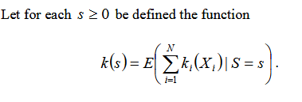.………………………… (5.3)

Then *k(s)* is a valid compensation function and

from

 is a valid reinsurer efficiency function. This we prove in the main and final theorem.

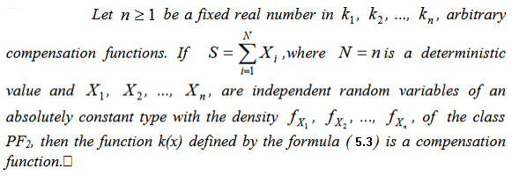

This confirms that the PF2 risks are locally additive, and the right side of equation (5.3) represents a compensation function and *X - k(x)* is a global retention function that can be used for risk reduction and increase in reinsurer’s efficiency.

Because the primary goal of an insurance company's effective portfolio formation is to redistribute risk in order to reduce its aggregate value while maintaining an acceptable level of profitability, forming an effective portfolio composition is one of the primary tasks of analytical management in insurance companies. This study considers the challenge of efficient portfolio creation in the reinsurance market. Linear programming can be applied to various aspects of risk management. One common application is in portfolio optimization, where the goal is to construct an investment portfolio that maximizes returns while minimizing risk. The linear programming problem in risk management [28-31] can be formulated as follows:

**Objective**: Maximize the expected return of the portfolio

**Constraints**:

**1. The total investment amount should not exceed the available budget.**

**2. The portfolio should meet certain risk constraints, such as a maximum allowable volatility or a target value-at-risk.**

**3. The weights assigned to each asset in the portfolio should sum up to 1 (indicating a fully invested portfolio).**

By formulating these constraints and objectives, linear programming techniques can be used to solve for the optimal allocation of investments that balances risk and return. The resulting solution provides the weights of each asset in the portfolio, allowing risk managers to make informed decisions and

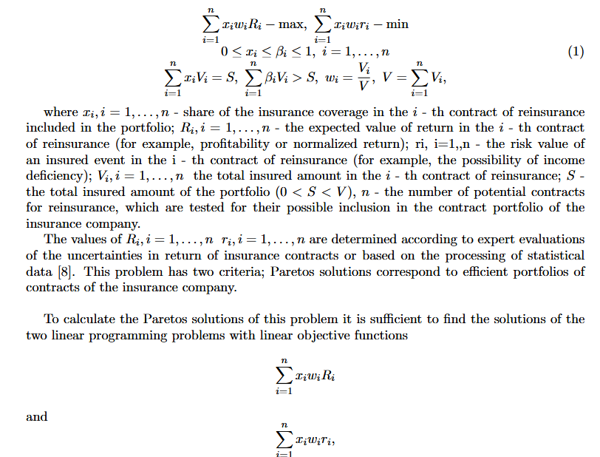manage risk effectively. It's important to note that the specific formulation and constraints of the linear programming problem may vary depending on the specific risk management objectives and constraints of the organization.

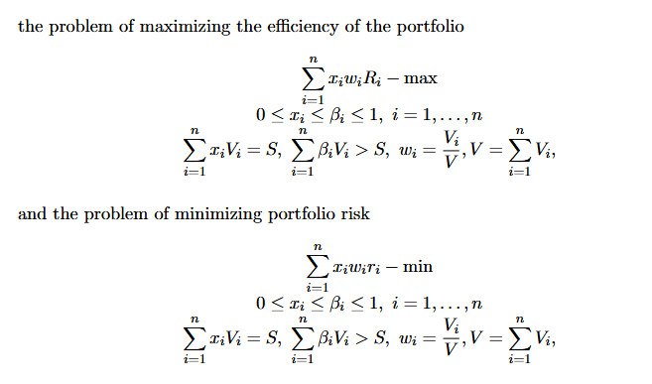

CHAPTER 5

RESULTS AND DISCUSSIONS

The solution methodology for arbitrary dimensions are suggested below that can be used in ML Ops based representation for machine learning of reinsurer efficiency. MATLAB based simulations are also useful in visualizing certain trends prescribed in the model.

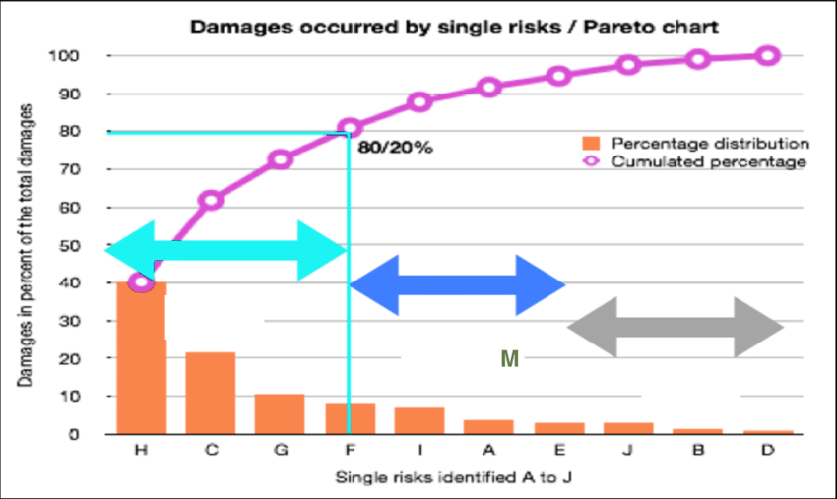

**Figure 3: Risk Management in Reinsurance: a Pareto chart for linearized problems**

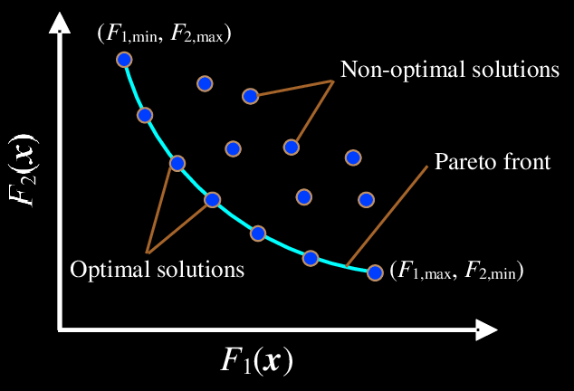

**Figure 4: Example of Pareto front solutions resembling rectangular hyperbola.**

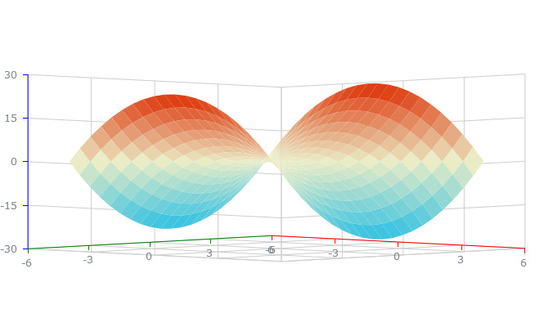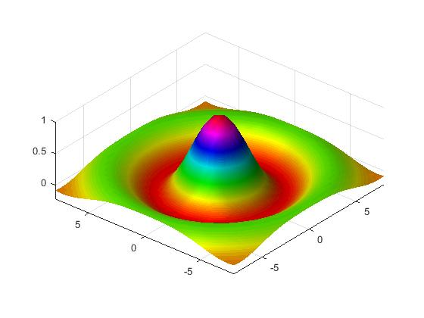

**Figure 5: Various Retention and compensation profiles for bivariate claims**

Pareto optimal solutions in reinsurance and risk analysis refer to a concept in which no party involved can be made better off without making another party worse off. This concept is derived from Pareto efficiency, which is a fundamental idea in economics and decision-making. In the context of reinsurance and risk analysis, Pareto optimal solutions are relevant for optimizing the allocation of risk between the insurer and the reinsurer. Reinsurance is a common practice in the insurance industry, where insurance companies transfer a portion of their risk to reinsurers to limit their exposure. In this context, Pareto optimal solutions help find the most efficient and equitable way to distribute risks and rewards between the insurer and the reinsurer. When an insurer and a reinsurer enter into a reinsurance contract, they need to determine how to allocate the premium and the responsibility for claims in a way that is mutually beneficial. Pareto optimality ensures that the risk-sharing arrangement is efficient and fair.

The concept of Pareto optimality helps in understanding trade-offs in risk analysis. For example, increasing the insurer's retention (the portion of risk they keep) might reduce their reinsurance costs, but it could also increase their exposure to large losses. The goal is to find a balance that maximizes both parties' utility, i.e., the insurer's profit and the reinsurer's premium income. Pareto optimal solutions aim to find a point where no further changes in the risk-sharing arrangement can make one party better off without making the other worse off. This represents an efficient allocation of risk and resources. In the process of risk analysis, insurers and reinsurers use various models and methods to assess and quantify risks. Pareto optimal solutions can help in determining the right mix of insurance and reinsurance to achieve a balance between risk exposure and risk transfer. When insurance and reinsurance contracts are negotiated, Pareto optimality can guide the discussions and help both parties arrive at an agreement that is mutually beneficial and equitable. To achieve Pareto optimality in reinsurance and risk analysis, mathematical models, optimization techniques, and negotiation skills are often employed. It's important to note that achieving Pareto optimality may not always be possible due to the complexity of risk factors, but it remains a valuable concept for guiding decision-making in this field. Pareto efficiency, or Pareto optimality, is typically defined using the Pareto dominance criteria. Given a set of allocations (e.g., risk-sharing arrangements) between two parties (insurer and reinsurer), an allocation is considered Pareto efficient if there is no other allocation that can make one party better off without making the other party worse off. Mathematically, an allocation (x, y) is Pareto efficient if there is no (x', y') such that x' is weakly better for one party, and y' is weakly better for the other party (i.e., there is no improvement without making someone worse off).

To formalize the concept of Pareto optimality, you often need to model the preferences and utilities of the insurer and the reinsurer mathematically. Utility functions are commonly used to represent how each party values different risk-sharing arrangements. These functions quantify the level of satisfaction or profit associated with different allocation choices. Techniques from mathematical optimization, such as linear programming, non-linear programming, and stochastic programming, can be applied to find Pareto optimal solutions. In these optimization problems, the goal is to find an allocation that maximizes the utility or profit of one party (e.g., insurer) while satisfying constraints that ensure the other party (e.g., reinsurer) receives an acceptable level of compensation. Risk analysis often involves probabilistic modeling. Insurers and reinsurers use mathematical models to estimate the probability of different risk scenarios and their associated financial outcomes. Techniques like Monte Carlo simulation are used to simulate various risk scenarios and evaluate the impact of different risk-sharing arrangements.

**5.1 Multi-Criteria Decision Analysis (MCDA)**: MCDA is a mathematical method used to consider multiple conflicting criteria simultaneously. In the context of reinsurance, it can be used to balance the preferences of both the insurer and reinsurer by assigning weights to various criteria, such as profitability, risk exposure, and premium income. In practice, finding Pareto optimal solutions in reinsurance and risk analysis often involves a combination of these mathematical approaches. Models are constructed based on historical data and assumptions about future risks, and optimization techniques are used to search for the allocation that maximizes the welfare of both parties while respecting their preferences and constraints. Additionally, sensitivity analysis may be performed to assess the robustness of the solution to changes in parameters or market conditions.

Game theory is another mathematical framework used in reinsurance and risk analysis. It can model the strategic interactions between the insurer and reinsurer, helping to understand their decision-making processes and find equilibria that might lead to Pareto optimal outcomes.

Game theory, reinsurance, and linear programming can be related in the context of optimizing reinsurance contracts and risk-sharing arrangements. Let's explore how these concepts are interconnected:

1. **Game Theory in Reinsurance**:
   * Game theory is a mathematical framework that studies strategic interactions between rational decision-makers. In the context of reinsurance, it can model the negotiations and strategic choices made by insurers and reinsurers.
   * The insurer and reinsurer are like players in a game, each with their preferences, strategies, and utility functions. They engage in negotiations to determine the terms of a reinsurance contract.
   * Game theory can help analyze the strategic behavior of the insurer and reinsurer during these negotiations. It can model scenarios where both parties try to maximize their utility or profit.

Game theory, reinsurance, and linear programming can be related in the context of optimizing reinsurance contracts and risk-sharing arrangements. Let's explore how these concepts are interconnected:

1. **Game Theory in Reinsurance**:
   * Game theory is a mathematical framework that studies strategic interactions between rational decision-makers. In the context of reinsurance, it can model the negotiations and strategic choices made by insurers and reinsurers.
   * The insurer and reinsurer are like players in a game, each with their preferences, strategies, and utility functions. They engage in negotiations to determine the terms of a reinsurance contract.
   * Game theory can help analyze the strategic behavior of the insurer and reinsurer during these negotiations. It can model scenarios where both parties try to maximize their utility or profit.
2. **Linear Programming in Reinsurance**:
   * Linear programming is an optimization technique used to find the best allocation of resources or decisions that maximize (or minimize) a linear objective function, subject to linear constraints.
   * In reinsurance, linear programming can be applied to find the optimal allocation of risk-sharing arrangements between the insurer and the reinsurer, considering various objectives, constraints, and preferences.
   * Linear programming models can be used to optimize the terms of a reinsurance contract, such as determining the optimal retention level for the insurer or deciding the proportion of risk to transfer to the reinsurer.
3. **Integration of Game Theory and Linear Programming**:
   * The integration of game theory and linear programming can help in finding Pareto optimal solutions in reinsurance contracts.
   * Game theory can model the strategic interactions between the insurer and reinsurer, considering their preferences and strategies during negotiations.
   * Linear programming can be employed to solve the optimization problem that arises from the game-theoretic model. This optimization seeks to find the reinsurance terms that maximize the combined utility or profit of both parties while respecting their strategic choices and constraints.
   * In this integrated approach, game theory informs the objective and constraints of the linear programming model, helping to account for the strategic behavior and preferences of the parties involved.

By combining game theory and linear programming, it becomes possible to design reinsurance contracts that not only consider the financial aspects of risk transfer but also account for the strategic and competitive elements of the negotiation process. This can lead to more efficient and equitable risk-sharing arrangements in the reinsurance industry.

Linear programming (LP) can be applied in reinsurance networks to optimize various aspects of risk management and financial decision-making. Reinsurance networks involve multiple insurers, reinsurers, and potentially retrocessionaires (companies that provide reinsurance to reinsurers). Here's how LP can be used in reinsurance network scenarios:

1. **Optimal Risk Allocation**:
   * LP can be used to optimize the allocation of risks among different insurers and reinsurers within a reinsurance network. It can help determine how much risk each party should retain and how much they should cede to others to minimize overall risk exposure and cost.
2. **Portfolio Optimization**:
   * Reinsurance networks often involve managing diverse portfolios of risks. LP can assist in optimizing the allocation of risk and capital across these portfolios to achieve financial objectives while adhering to regulatory constraints.
3. **Reinsurance Contract Design**:
   * LP can be used to design reinsurance contracts within the network. This involves determining optimal premium structures, retention levels, and coverage limits, balancing the needs of insurers and reinsurers while ensuring financial stability.
4. **Capital Management**:
   * LP can help optimize the allocation of capital among various insurers and reinsurers in the network. This ensures that capital is efficiently deployed to cover risks while meeting solvency requirements.
5. **Risk Mitigation Strategies**:
   * LP models can be used to assess different risk mitigation strategies within a reinsurance network. For instance, LP can determine the optimal use of retrocession arrangements, including the selection of retrocession Aires and the allocation of ceded risk.
6. **Efficiency and Cost Minimization**:
   * LP can optimize the overall cost structure of reinsurance operations in the network, including premium expenses, commissions, and operational costs. This can lead to cost-efficient reinsurance management.
7. **Stochastic Modelling**:
   * In situations where risks are uncertain and subject to probability distributions, LP can be combined with stochastic programming to account for random variables. This helps in making decisions under uncertainty and volatility, which is common in reinsurance.
8. **Regulatory Compliance**:
   * LP can be used to ensure that the reinsurance network complies with regulatory requirements, such as solvency margins and capital adequacy ratios.
9. **Market Dynamics**:
   * LP models can factor in market dynamics and competitive pressures within the reinsurance industry to optimize pricing strategies and risk transfer arrangements.
10. **Optimal Reinsurance Network Structure**:
    * LP can be employed to determine the most effective structure of the reinsurance network, including the selection of reinsurers and retrocession Aires, taking into account their financial strength and risk appetites.

Linear programming, when combined with mathematical optimization techniques, can help reinsurance networks make informed decisions that balance the objectives of risk reduction, profitability, and regulatory compliance. These models provide a systematic and quantitative approach to managing complex portfolios of risks in the insurance and reinsurance industry. Linear programming problems (LPPs) involve optimizing a linear objective function subject to linear constraints. Visualizing LPPs can be helpful for understanding and solving such problems. Commonly used graphical tools for this purpose include feasible region plots and objective function plots. Here, I'll describe both types of plots:

1. **Feasible Region Plot**:
   * A feasible region plot represents the area in the decision variable space where all constraints are satisfied. The optimal solution to an LPP lies at one of the extreme points (vertices) of this feasible region.
   * Consider a simple two-variable LPP with the following constraints:
     + Constraint 1: 2x + 3y ≤ 12
     + Constraint 2: x + 2y ≤ 6
     + Non-negativity: x ≥ 0, y ≥ 0
   * To create a feasible region plot, you would graph these constraints on a coordinate plane and shade the region where all constraints are satisfied. The feasible region would be the intersection of the shaded areas.
   * The optimal solution (maximum or minimum) will be at one of the corners or vertices of this feasible region.
   * Here's an example of what a feasible region plot might look like:
2. **Objective Function Plot**:
   * An objective function plot shows how the objective function (the linear function you want to optimize) changes as you move along a particular direction in the decision variable space.
   * Suppose you have an objective function F(x, y) = 4x + 3y, and you want to maximize it. You can create an objective function plot by fixing one variable (e.g., x) and varying the other variable (y) over a range.
   * For instance, you can set x = 0 and calculate F(0, y) for various values of y. Then, plot these points to visualize how F changes with y.
   * Fig. 4 and 5 each is an example of an objective function plot:
   * The optimal solution will be where the objective function reaches its maximum value within the feasible region.

These plots are particularly useful for understanding the geometry of LPPs, identifying feasible solutions, and gaining insights into the relationships between decision variables and the objective function. They provide visual aids that help in solving linear programming problems and interpreting the results.

Top of Form

A risk matrix is a popular tool used for risk classification and prioritization. It categorizes risks based on their likelihood (probability) and impact (severity) to determine their overall risk level. The risk matrix typically consists of a grid with different levels of likelihood and impact, and each intersection represents a specific risk classification. Here is a common classification scheme for a risk matrix:

**1. High Risk (Red Zone):** Risks falling in this zone have both a high likelihood and a high impact. These risks are considered critical and require immediate attention and mitigation strategies.

**2. Medium Risk (Yellow Zone):** Risks in this zone have either a moderate likelihood and high impact, or high likelihood and moderate impact. These risks are significant and should be closely monitored and managed to prevent them from escalating.

**3. Low Risk (Green Zone):** Risks in this zone have either a low likelihood and high impact, or high likelihood and low impact. While these risks may not require immediate action, they should still be monitored and managed to prevent any potential negative consequences.

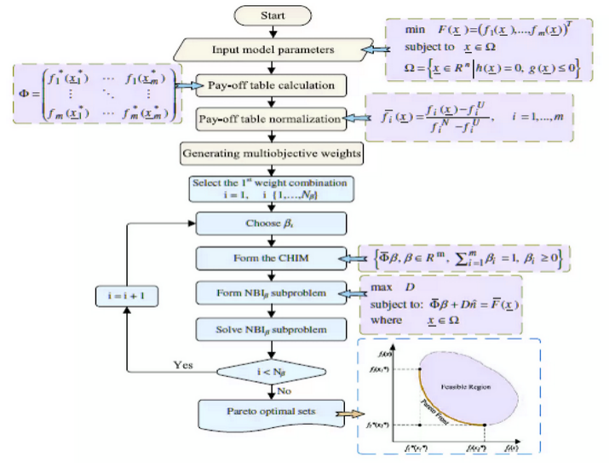

**Figure 6: Risk reduction by multi-objective optimization for Pareto solutions: a schematic.**

**4. Negligible Risk (Blue Zone):** Risks falling in this zone have both a low likelihood and low impact. These risks are considered minor and may not require significant attention or resources. However, they should still be periodically reviewed and assessed.

It is important to note that the specific classification scheme and color coding used in a risk matrix may vary depending on the organization or industry. The purpose of the risk matrix is to visually represent the relative levels of risk and aid in decision-making for risk management strategies.

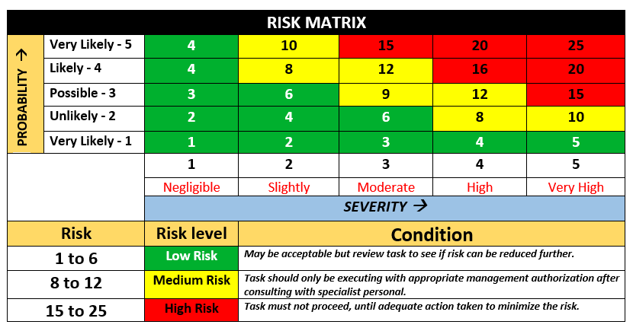

**Figure 7: Risk Management through risk matrix structure**

A risk matrix and the concept of Pareto optimality can be valuable tools in reinsurance to assess and optimize risk management strategies. Let's explore how they are related and how they can be used together:

1. Risk Matrix:
   * A risk matrix is a visual representation of risks, typically used in risk assessment and management. It classifies risks based on their likelihood and impact, creating a grid where each cell corresponds to a risk category. Common classifications include low, medium, and high likelihood and impact.
   * In reinsurance, a risk matrix can help identify and assess the various risks that an insurer faces. These risks can include natural disasters, financial downturns, underwriting risks, and more.
   * The risk matrix allows insurers and reinsurers to prioritize risks, understand their potential impact, and allocate resources for risk mitigation and transfer accordingly.
2. Pareto Optimality:
   * Pareto optimality, also known as Pareto efficiency, is a concept in economics and optimization. It refers to a situation in which no party can be made better off without making another party worse off. In other words, it represents an allocation of resources where it's not possible to improve one party's situation without harming someone else.
   * In reinsurance, achieving Pareto optimality means finding an allocation of risk-sharing arrangements that maximizes the welfare of both the insurer and the reinsurer, considering their preferences and constraints.

How are they related in reinsurance?

* The risk matrix can help identify and quantify risks. By classifying risks based on their likelihood and impact, it provides a structured way to prioritize them.
* **Pareto optimality comes into play when determining how to allocate and manage these risks efficiently between the insurer and the reinsurer. Pareto optimal solutions ensure that the insurer and reinsurer both achieve the best possible outcomes given their risk-sharing arrangement.**
* **Insurers and reinsurers can use the information from the risk matrix to assess the potential impact of different risk allocation strategies and reinsurance contracts. They can then employ Pareto optimality to optimize these strategies.**
* **By seeking Pareto optimal solutions, insurers and reinsurers aim to find a balance in their risk-sharing arrangement that maximizes their combined utility or profit, taking into account the risk matrix's findings.**

**In practice, the risk matrix provides valuable information for risk assessment and prioritization, while Pareto optimality offers a framework for decision-making that ensures a fair and efficient allocation of risk within the reinsurance agreement. Together, they can help insurers and reinsurers make informed decisions about risk management and optimize their reinsurance contracts.**

Risk management is a critical process for organizations seeking to navigate the uncertain and dynamic landscape of business and project management. It involves identifying, assessing, prioritizing, and mitigating risks to protect assets, achieve objectives, and enhance decision-making. Two essential tools in risk management are the risk matrix and Linear Programming (LP). This essay explores the concepts of a risk matrix and LP and their combined utility in managing risks effectively. While the risk matrix is a qualitative tool, LP adds quantitative rigor to the risk management process. By combining these two approaches, organizations can develop a more comprehensive risk management strategy. We use the result of the Pareto front to classify the risk regions for a given reinsurance contract with PF2 type claims.

LP allows for a quantitative analysis of risk exposure. Instead of relying solely on the qualitative classifications of a risk matrix, LP can incorporate numerical values representing likelihood, impact, and even mitigation costs. LP can help organizations optimize resource allocation to minimize risk. By modeling resource constraints and risk exposures, LP identifies the most efficient allocation that minimizes the overall risk profile. It can analyze various scenarios, allowing organizations to consider multiple risk scenarios simultaneously. By running LP models with different inputs representing various risk scenarios, decision-makers can develop robust strategies that account for a range of outcomes. Most importantly, we show that LP can be used to determine the best course of action in the presence of multiple objectives. For example, it can identify the resource allocation that maximizes profit while minimizing risk exposure. In the realm of decision-making and risk management, the integration of multi-objective optimization techniques with traditional tools such as the risk matrix and Linear Programming (LP) offers a powerful approach to address complex challenges. Multi-objective optimization (MOO) focuses on simultaneously optimizing multiple conflicting objectives, a scenario often encountered in decision-making where one has to balance risks, costs, and benefits. This essay explores the connection between multi-objective optimization, the risk matrix, and LP and how this integrated approach can enhance robust decision-making. Multi-objective optimization is a mathematical methodology designed to find the best trade-offs among multiple conflicting objectives. It arises in a variety of practical situations where a single optimal solution may not exist because objectives are in competition. For instance, in project management, objectives like cost minimization, time minimization, and quality maximization often conflict. MOO techniques seek to identify a set of solutions, known as the Pareto front, where no solution is better than another in all objectives.

In the context of risk management, objectives often include risk mitigation, cost reduction, and profit maximization. Multi-objective optimization enables organizations to explicitly define and prioritize these objectives and their associated constraints. he risk matrix, with its ability to assess and prioritize risks based on likelihood and impact, provides input to MOO. Each risk's assessed impact and likelihood are treated as objective functions, and their corresponding positions in the matrix help determine constraints and preferences in the optimization process. Linear Programming complements the integration by addressing the quantitative aspects of risk management. It can be used to model resource allocation, budget constraints, and the relationships between risks, and their potential impact on decision variables. LP's capability to handle linear constraints and objectives aligns well with MOO. The integration balances conflicting objectives, such as minimizing risks versus maximizing profit. Decision-makers can use MOO to explore a range of solutions that provide different trade-offs, allowing for a more comprehensive understanding of the decision space. By incorporating MOO, organizations can achieve more robust decision-making. Robust solutions are those that perform well across various scenarios and uncertainties. MOO helps identify solutions that are less sensitive to risk and are better suited to withstand uncertainties.

Risk management plays a pivotal role in helping organizations and individuals make informed decisions that balance potential gains and losses. Understanding and addressing risks is crucial for achieving goals and safeguarding against unforeseen events. The risk matrix structure is a visual and analytical tool that aids in systematically evaluating risks. It enables organizations to assess the probability and impact of various risks and prioritize their management strategies accordingly.

This essay will first introduce the fundamentals of risk management and then delve into the risk matrix structure as an essential tool for this purpose. It will discuss how risk matrices work, their components, and different risk assessment methods. Subsequently, the essay will explore how risk matrices are used in different sectors and industries, including finance, healthcare, project management, and insurance. It will also provide insights into their advantages and limitations.

**5.2. Understanding Risk Management:**

Risk management is the process of identifying, assessing, prioritizing, and mitigating risks to achieve organizational objectives while minimizing potential negative outcomes. It involves a structured approach to handling uncertainty and making informed decisions in the face of various challenges.

**5.2.1. Key Steps in Risk Management:**

* *Identification of Risks*: The first step in risk management is to identify potential risks. Risks can be internal or external, known or unknown, and they may arise from various sources.
* *Risk Assessment*: Once risks are identified, they need to be assessed in terms of their probability and potential impact. This assessment forms the basis for prioritizing risks.
* *Risk Prioritization*: Not all risks are equal. Some may have a higher probability of occurrence or a more significant impact. Organizations prioritize risks to focus their resources and attention on the most critical issues.
* *Risk Mitigation and Monitoring*: After risks are identified and prioritized, risk management strategies are put in place. These strategies can include risk avoidance, risk reduction, risk transfer, or acceptance. Risks are continually monitored to ensure that the mitigation strategies remain effective.

**5.3. The Risk Matrix Structure:**

The risk matrix, often referred to as a risk assessment matrix, risk priority matrix, or risk heat map, is a graphical tool that helps organizations assess and prioritize risks. It provides a systematic approach to understanding the likelihood and impact of various risks, helping organizations make decisions based on a clear understanding of potential consequences.

**5.3.1. Components of a Risk Matrix:**

A typical risk matrix includes the following components:

* *Risk Categories*: Risks are categorized based on their nature. For example, in healthcare, risks may be categorized as clinical, operational, financial, and strategic.
* *Likelihood*: This represents the probability of a risk occurring. Likelihood is often categorized as low, moderate, or high.
* *Impact*: Impact measures the severity of the consequences if a risk materializes. It is also categorized as low, moderate, or high.
* *Risk Scores*: The combination of likelihood and impact provides a risk score, which helps in prioritizing risks. High likelihood and high impact risks are considered the most critical.
* *Risk Actions*: Risk matrices often include a section for defining risk actions, which are strategies or measures to mitigate or manage risks.

**5.3.2. The Risk Assessment Process:**

The risk assessment process using a risk matrix typically involves the following steps:

* **Identify Risks**: The first step is to identify potential risks that an organization or project might face. This could involve brainstorming, historical data analysis, or expert input.
* **Categorize Risks**: Once identified, risks are categorized based on their nature and potential impact. This step helps in structuring the risk assessment.
* **Assess Likelihood and Impact**: Each risk is assessed in terms of its likelihood of occurrence and its potential impact on the project or organization. These assessments are often performed on a numerical scale, such as 1 to 5, or they can be represented as low, moderate, or high.
* **Calculate Risk Scores**: Risk scores are calculated by multiplying the likelihood and impact scores. For example, if the likelihood is rated as 3 and the impact as 4, the risk score would be 12.
* **Prioritize Risks**: Risks are then prioritized based on their risk scores. High-risk scores are considered the most critical and require immediate attention.
* **Define Risk Actions**: Once risks are prioritized, risk actions are defined. These actions could include risk mitigation strategies, contingency plans, or monitoring procedures.
* **Regular Review**: The risk matrix is not static. It should be reviewed and updated regularly as circumstances change, new information becomes available, or as risks evolve.

**5.4. Applications of Risk Matrices:**

The risk matrix structure is widely used in various sectors to assess and manage risks effectively. Here, we will explore how it is applied in finance, healthcare, project management, and insurance.

**5.4.1. Finance:**

In finance, risk management is crucial for investors, financial institutions, and portfolio managers. Risk matrices are employed to assess the potential risks associated with various investment options. The matrix helps investors balance the trade-off between risk and return.

* **Investment Risk Assessment**: Risk matrices are used to assess the likelihood and impact of various financial risks, such as market risk, credit risk, liquidity risk, and operational risk. Investors and portfolio managers can use risk matrices to make informed decisions about asset allocation.
* **Portfolio Diversification**: By evaluating the risks associated with different investment options, investors can create diversified portfolios that spread risk across various asset classes, reducing the impact of adverse events.
* **Stress Testing**: Financial institutions use risk matrices for stress testing scenarios to understand how potential economic downturns or extreme events can affect their financial stability. This helps in capital planning and risk mitigation strategies.

**5.4.2. Healthcare:**

In healthcare, the use of risk matrices is essential for patient safety, regulatory compliance, and the management of clinical and operational risks.

* **Patient Safety**: Healthcare providers use risk matrices to assess clinical risks, such as patient complications, medication errors, and infections. By identifying high-risk areas, hospitals can implement measures to enhance patient safety.
* **Operational Risk**: Hospitals and healthcare organizations use risk matrices to manage operational risks, which can include supply chain disruptions, equipment failures, and cybersecurity threats.
* **Regulatory Compliance**: Risk matrices are valuable for ensuring compliance with healthcare regulations. By identifying and mitigating risks related to regulatory non-compliance, organizations avoid penalties and legal consequences.

**5.4.3. Project Management:**

Risk management is a critical aspect of project management, where numerous uncertainties and variables can impact project success.

* **Project Risk Assessment**: Risk matrices help project managers assess the potential risks associated with a project, including scope changes, delays, budget overruns, and resource constraints. By understanding these risks, project managers can develop mitigation strategies.
* **Resource Allocation**: Risk matrices aid in resource allocation. They help project managers allocate resources to high-impact, high-likelihood risks to ensure the project's success.
* **Project Prioritization**: When organizations have multiple projects in their portfolio, risk matrices help prioritize projects by assessing the potential risks and aligning project priorities with organizational goals.

**5.4.4. Insurance:**

Risk matrices are a fundamental tool in the insurance industry for evaluating, pricing, and underwriting risks.

* **Risk Assessment for Underwriting**: Insurers use risk matrices to evaluate the risks associated with potential policyholders. By understanding the likelihood and impact of risks, insurers can determine appropriate coverage and premiums.
* **Pricing of Insurance Policies**: Risk matrices inform the pricing of insurance policies. Insurers assess the potential risks of providing coverage to policyholders, and premiums are calculated based on these risk assessments.
* **Claims Management**: In the claims management process, risk matrices help insurers assess the validity of claims. They aid in determining the extent of coverage and claim settlements.

**5.5. Advantages and Limitations of Risk Matrices:**

**5.5.1. Advantages:**

* **Simplicity**: Risk matrices provide a simple and intuitive way to visualize risks. They are accessible to stakeholders at various levels of expertise.
* **Prioritization**: By assigning risk scores, risk matrices allow for the prioritization of risks. This enables organizations to focus their attention and resources on the most critical issues.
* **Communication**: Risk matrices facilitate effective communication by providing a common visual language for discussing risks. They help stakeholders understand the potential consequences of various risks.
* **Decision Support**: Risk matrices offer valuable support for decision-making. They help organizations make informed choices by aligning risks with objectives.

**5.5.2. Limitations:**

* **Subjectivity**: Risk matrices rely on subjective assessments of likelihood and impact. Different stakeholders may assign different scores to the same risk, leading to inconsistencies.
* **Qualitative Nature**: Risk matrices are primarily qualitative tools, which can limit their ability to precisely quantify and compare risks. For more accurate risk assessments, quantitative methods may be required.
* **Overemphasis on High-Impact Risks**: Risk matrices can sometimes overemphasize high-impact risks while neglecting lower-impact but high-frequency risks, which can also be significant over time.
* **Lack of Sensitivity to Changes**: Risk matrices may not be sensitive to changes in risk assessments. A slight adjustment in likelihood or impact scores can result in significant changes in risk prioritization.

The risk matrix structure is a valuable tool for risk management across various sectors, allowing organizations and individuals to systematically assess and prioritize risks. By understanding the likelihood and impact of different risks, stakeholders can make informed decisions, allocate resources effectively, and implement mitigation strategies to enhance their chances of success.

While risk matrices offer several advantages, including simplicity, prioritization, and effective communication, they also come with limitations, such as subjectivity and a qualitative nature. Therefore, to address these limitations, organizations can combine risk matrices with more quantitative risk assessment methods for a comprehensive and accurate risk management approach.

In conclusion, risk matrices are a versatile and practical tool that plays a pivotal role in managing risks, ensuring patient safety, making informed investment decisions, delivering successful projects, and providing insurance coverage that aligns with organizational objectives. When used in conjunction with other risk management strategies, risk matrices are a key element of a comprehensive risk management framework that empowers organizations to navigate uncertainties and challenges effectively.

**Required Resources**

16 GB RAM, 32 GB free space, Ports

1x USB 3.2 Gen 1, 1x USB 3.2 Gen 1 (Always On), 1x USB-C 3.2 Gen 1 (support data transfer, Power Delivery 3.0 and DisplayPort 1.4),1x USB-C 3.2 Gen 2 (support data transfer, Power Delivery 3.0 and DisplayPort 1.4), 1x HDMI 1.4b, 1x Ethernet (RJ-45), 1x Headphone / microphone combo jack (3.5mm)

**Processor**

AMD Ryzen™ 3 7330U Processor (2.30 GHz up to 4.30 GHz)

**Operating System**

Windows 10/LINUX

**Memory**

8 GB Soldered DDR4 3200MHz

**Hard Drive**

256 GB SSD M.2 2242 PCIe Gen4 TLC Opal

**Display Type**

40.64cms (16) WUXGA (1920 x 1200), IPS, Anti-Glare, Non-Touch, 45%NTSC, 300 nits

**Graphics**

Integrated Graphics

**Wireless**

Realtek RTL8852BE Wi-Fi 6 11AX (2x2) & Bluetooth® 5.1

Reinsurance Dataset, Python Libraries, ML Ops, MATLAB and Mathematica 11. TensorFlow, Py Tech. LaTeX for mathematical writing with MikTeX.

CHAPTER 6

CONCLUSIONS AND RECOMMENDATIONS

Monotonicity in reinsurance is a mathematical concept used in pricing and risk assessment. It relates to the relationship between the amount of risk retained by the ceding insurance company and the compensation paid to the reinsurer. Monotonicity is often considered when determining how much risk the reinsurer assumes and how much compensation they receive. The monotonicity principle, in the context of reinsurance, suggests that as the ceding insurance company retains more risk (i.e., increases its retention), the compensation paid to the reinsurer should increase accordingly. This principle ensures that the reinsurer is fairly compensated for taking on additional risk. Reinsurance is a mechanism for transferring risk from the ceding insurer to the reinsurer. By retaining more risk, the ceding insurer essentially self-insures to a greater extent. This means that the reinsurer's exposure to potential losses decreases as the ceding insurer's retention increases. Reinsurance contracts are structured with various compensation components, such as premiums, commissions, and profit-sharing arrangements. The compensation to the reinsurer should reflect the level of risk they are assuming. As the ceding insurer retains more risk, it is reasonable for the reinsurer to expect higher compensation.

Monotonicity helps in achieving a balance between risk and reward. The reinsurer should be incentivized to take on additional risk but should also be compensated fairly for doing so. The concept ensures that the compensation structure aligns with the risk assumed. Reinsurance contracts can be customized to reflect the specific risk-sharing arrangement between the ceding insurer and the reinsurer. This may involve setting different retention levels for various types of policies or lines of business, and adjusting compensation accordingly. Reinsurance contracts can be customized to reflect the specific risk-sharing arrangement between the ceding insurer and the reinsurer. This may involve setting different retention levels for various types of policies or lines of business and adjusting compensation accordingly. Regulatory bodies often require that reinsurance contracts adhere to principles of fairness and consistency. Monotonicity helps ensure that compensation is reasonable and that the risk transfer process is transparent and equitable. In summary, monotonicity in reinsurance is related to the principle that the relationship between the risk retained by the ceding insurer and the compensation paid to the reinsurer should be proportional and fair. It helps maintain a balance between risk and reward, encourages risk-based pricing, and ensures that the compensation structure aligns with the level of risk assumed by the reinsurer. This principle is essential for effective and equitable risk-sharing in the reinsurance industry.

Polya frequency functions are valuable tools in reinsurance for modelling the distribution of loss events, assessing risk, and making informed decisions. These functions offer insurers a quantitative framework for understanding the frequency and severity of claims, tail risk, and the overall risk exposure within their portfolios. By leveraging Polya frequency functions, reinsurance companies can better manage and mitigate risks, set appropriate premiums, allocate capital efficiently, and enhance their ability to withstand adverse scenarios. This approach contributes to the resilience and long-term success of reinsurance operations in a dynamic and evolving industry. We have shown that the local constitutive risks follow Polya frequency functions then the total risk is Polya too. Polya frequency functions can play a role in the pricing and underwriting of reinsurance contracts. By analysing the frequency and severity of past loss events, insurers can set appropriate premiums, assess risk levels, and make informed underwriting decisions. Effective capital allocation is critical in reinsurance to ensure financial stability. Polya frequency functions help insurers determine the capital needed to cover potential losses. This information is crucial for maintaining solvency and meeting regulatory requirements. Reinsurance companies use stress testing to assess how their portfolios would perform under extreme conditions. Polya frequency functions can be incorporated into stress testing scenarios, enabling insurers to evaluate their ability to withstand rare and severe loss events.

While Polya frequency functions offer numerous benefits in reinsurance, it's essential to recognize that they are statistical models and, like any model, come with limitations. These functions are most suitable for data with discrete, non-negative values. Additionally, the choice of the appropriate Polya distribution parameters can significantly impact the accuracy of modelling. Careful attention to data quality and the model's assumptions is crucial. Reinsurance companies often deal with a diverse portfolio of policies, each with its unique risk profile. Polya frequency functions can aid in portfolio diversification by providing a statistical basis for assessing the aggregate risk across different lines of business. This enables insurers to optimize their risk exposure and capital allocation. Understanding tail risk, which refers to the potential for rare and extreme loss events, is crucial in reinsurance. Polya frequency functions can be used to model the tail behaviour of loss event distributions, helping insurers identify and manage tail risks effectively. This is particularly important for catastrophic events and large-scale losses. In reinsurance, it is crucial to understand the frequency of claim occurrences. Polya frequency functions can be used to model the distribution of claim frequency, helping reinsurance companies estimate the likelihood of various claim scenarios. By characterizing the distribution of claims, insurers can better assess and manage their exposure to loss events. Polya frequency functions indeed provide a valuable framework for risk assessment in the context of reinsurance. Risk assessment is a critical aspect of reinsurance, as it involves evaluating and understanding the potential losses that an insurer might face and developing strategies to mitigate these risks effectively. Polya frequency functions are well-suited for modelling the frequency of loss events, such as insurance claims. In reinsurance, it's essential to quantify how often certain types of losses occur. By fitting Polya frequency functions to historical claims data, insurers can gain insights into the distribution of claim frequency. This information helps them estimate the likelihood of different claim scenarios, which is crucial for pricing, underwriting, and capital allocation decisions. · Reinsurance companies often face the challenge of dealing with tail risk, which involves the potential for rare and extreme loss events. Polya frequency functions can be used to model the tail behaviour of loss event distributions. By focusing on the tail of the distribution, insurers can gain a deeper understanding of the most extreme and infrequent claims. This is particularly important for assessing the impact of catastrophic events or other rare but severe losses. Data-Driven Risk Assessment: Polya frequency functions rely on historical data, making them a data-driven approach to risk assessment. By analysing past loss events and fitting these functions to the data, insurers can identify trends, patterns, and probabilities associated with claims. This empirical approach provides a more accurate and objective basis for assessing risk, as opposed to relying solely on subjective assessments.

·

Effective portfolio formation for an insurance company involves carefully selecting and managing a diverse range of insurance policies to achieve a balanced and profitable portfolio while redistributing and managing risks. Here are some key steps and considerations:

**Risk Assessment and Analysis:**

Identify the types of insurance policies offered, such as life insurance, health insurance, property and casualty insurance, etc.

Assess the potential risks associated with each policy, considering factors like claims frequency, severity, and exposure to catastrophic events.

Analyse the historical performance of different policy types and their associated risks.

**Diversification:**

Diversify the portfolio by offering a mix of policies across different lines of insurance (e.g., life, health, auto, property).

Geographical diversification can help mitigate region-specific risks (e.g., natural disasters).

Diversify the policyholder base by targeting different customer segments.

**Reinsurance:**

Consider purchasing reinsurance to transfer a portion of the risk to other insurers or reinsurers.

Assess the level of reinsurance needed for various types of policies and risks.

Evaluate the financial stability and reputation of reinsurers.

**Risk Tolerance and Capital Allocation:**

Define the company's risk tolerance and capital allocation strategy.

Determine how much capital should be allocated to different types of policies based on risk assessment.

Allocate capital efficiently to optimize returns while maintaining financial stability.

**Underwriting and Pricing:**

Implement sound underwriting practices to select and price policies appropriately.

Avoid under pricing policies, as this can lead to adverse selection and underwriting losses.

Use data analytics and actuarial methods to set competitive yet profitable premiums.

**Claims Management:**

Establish effective claims management procedures to control claims costs.

Investigate and settle claims promptly and fairly.

Implement fraud detection measures to minimize fraudulent claims.

**Regular Monitoring and Adjustment:**

Continuously monitor the performance of the portfolio.

Adjust the mix of policies as market conditions, regulations, and risk factors change.

Review and revise risk management and reinsurance strategies as needed.

**Regulatory Compliance:**

Ensure that the insurance company complies with all relevant regulations and licensing requirements.

Stay informed about changing regulatory requirements that may impact portfolio formation and risk management.

**Stress Testing and Scenario Analysis:**

Conduct stress testing and scenario analysis to understand how the portfolio would perform under extreme conditions.

Use the results to assess capital adequacy and make adjustments to the portfolio as needed.

**Risk Management Framework:**

Develop a comprehensive risk management framework that incorporates risk identification, measurement, monitoring, and mitigation strategies.

Effective portfolio formation for an insurance company is a dynamic process that requires ongoing risk assessment and adaptation to changing market conditions and risk factors. It's essential to strike a balance between risk and return while ensuring the company's long-term financial stability and the protection of policyholders. Effective portfolio formation for an insurance company is an ongoing process that requires a deep understanding of risk, prudent management practices, and adaptability in a dynamic market environment. A well-constructed and diversified portfolio, combined with rigorous risk management, is essential for the long-term success and financial stability of an insurance company.

In reinsurance and risk management, probability distributions are used to model and analyse the potential risks and losses associated with insurance policies and contracts. Different probability distributions are used based on the characteristics of the risks being assessed.

**Normal Distribution (Gaussian Distribution):** The normal distribution is often used to model claims frequency (the number of claims) in reinsurance. It assumes that claims follow a bell-shaped curve, with most claims clustered around the mean, and fewer claims as you move away from the mean. This distribution is especially useful for modelling every day, common risks.

**Log-Normal Distribution:** The log-normal distribution is suitable for modelling claims severity (the amount of each claim) in reinsurance. It is characterized by a positively skewed distribution and is commonly used when dealing with financial or loss data. The log-normal distribution is often used to model catastrophic events or large losses.

**Pareto Distribution (Heavy-Tailed Distribution):** The Pareto distribution is used for modelling extreme events or tail risks. It has a heavy right tail, meaning it accounts for the possibility of rare but highly severe events. This distribution is relevant when assessing risks associated with catastrophic losses, such as natural disasters or large liability claims.

**Exponential Distribution:** The exponential distribution is often used to model the time between claims occurrences. It is useful for understanding the frequency of claims, such as the time between accidents in an auto insurance portfolio.

**Weibull Distribution:** The Weibull distribution is versatile and can be used to model various types of risks. It can be customized to fit data for both claims frequency and severity, making it useful for different types of reinsurance contracts.

**Gamma Distribution:** The gamma distribution is used to model aggregate claims, which are the total claims incurred over a specified period. It is relevant for modelling the accumulation of claims in reinsurance contracts.

Beta Distribution: The beta distribution is often used to model the distribution of loss ratios, which is the ratio of incurred losses to earned premiums in an insurance portfolio. It is useful for understanding the variability in underwriting results.

**Triangular Distribution:** The triangular distribution is used when limited data is available or when risk modelling requires a simplified approach. It is often used in reinsurance to simulate uncertainty in risk assessment.

**Mixture Distributions:** In some cases, reinsurance professionals use mixture distributions, which combine two or more probability distributions to capture more complex risk scenarios. For example, a mixture distribution might combine a normal distribution and a Pareto distribution to model both common and extreme events. The choice of probability distribution in reinsurance depends on the nature of the risks, the available data, and the specific objectives of the analysis. Reinsurance companies and risk analysts often use a combination of these distributions, statistical methods, and historical data to estimate and manage potential losses and to set appropriate reinsurance terms, premiums, and capital reserves.

The combination of a risk matrix and Linear Programming provides a holistic approach to risk management. The risk matrix offers a simple and intuitive method for identifying and assessing risks, while LP adds quantitative rigor, resource optimization, and scenario analysis. By integrating these tools, organizations can make more informed decisions, allocate resources efficiently, and develop strategies that are robust in the face of uncertainties. This comprehensive approach to risk management equips organizations to navigate complex and dynamic business environments while minimizing potential negative impacts and maximizing opportunities for success. The integration of multi-objective optimization, the risk matrix, and Linear Programming offers a comprehensive approach to decision-making and risk management. It enables organizations to explicitly define and balance multiple objectives, including risk mitigation, cost, and profit, while accounting for the complex interplay among them. By exploring a range of Pareto-optimal solutions, decision-makers can make informed choices that are better equipped to handle uncertainties and achieve robust outcomes. This integrated approach enhances the adaptability and resilience of organizations in dynamic and uncertain environments, contributing to more effective risk management and decision-making.

**References**

1. Lloyd's 360 Risk Project - Understanding Risk: A Review of Lloyd's Risk Management Tool.
2. Reinsurance Principles and Practice" by Brian Cochrane.
3. Principles of Risk Management and Insurance" by George E. Rejda.
4. Reinsurance Management: A Practical Guide" by David Atkinson.
5. Catastrophe Risk and Reinsurance: A Country Risk Management Perspective" by Céline G. L. Yeh.
6. Solvency II: Stakeholder Communications and Change" by Karel Van Hulle.
7. Alternative Risk Transfer: Integrated Risk Management Through Insurance, Reinsurance, and the Capital Markets" by Erik Banks.
8. Enterprise Risk Management: Today's Leading Research and Best Practices for Tomorrow's Executives" by John R. S. Fraser and Betty J. Simkins.
9. Reports from the Intergovernmental Panel on Climate Change (IPCC) and organizations like the Geneva Association.
10. Dantzig, G. B. (April 1982). ["Reminiscences about the origins of linear programming"](https://apps.dtic.mil/sti/pdfs/ADA112060.pdf) (PDF). *Operations Research Letters.* 1 (2): 43–48. [doi](https://en.wikipedia.org/wiki/Doi_(identifier)):[10.1016/0167-6377(82)90043-8](https://doi.org/10.1016/0167-6377(82)90043-8)

1. Sierksma, G. and Zwols, Y. (2015). *Linear and Integer Optimization: Theory and Practice*(3rd ed.). CRC Press. p. 1. [ISBN](https://en.wikipedia.org/wiki/ISBN_(identifier)) [978-1498710169](https://en.wikipedia.org/wiki/Special:BookSources/978-1498710169).
2. Deb, K. *Optimization for Engineering Design*, EEE 2nd Edition (2003)
3. Dasgupta, B. *Applied Mathematical Methods*, Prentice-Hall 2nd Edition (2007)
4. Kreyzig, E. *Advanced Engineering Matheatics*, EEE 2nd Edition (2003)
5. Balashov R B and Kryanev A V 2016 Vestnik Natsionalnogo Issledovatelskogo Yadernogo Universiteta MIFI 5 174–6
6. M. K. Gohil, A. Chakraborty and B. Dasgupta, "Hyper-redundant Robots and bioinformatics: Modelling loops in RNA," *2016 IEEE International Conference on Systems, Man, and Cybernetics (SMC)*, Budapest, Hungary, 2016, pp. 003694-003700, doi: 10.1109/SMC.2016.7844808.
7. Kryanev A V and Cherny A I 1996 Mathematical modeling 8 97–103
8. Pass C, Lowes B and Davies L 1998 COLLINS Dictionary of Economics (Saint Petersburg: Higher School of Economics)
9. Golubin A Y 2003 Mathematical models in the theory of insurance: construction and optimization (Moscow:Ankil)
10. A. Chakraborty, A. S. Roy and B. Dasgupta, "Non-parametric smoothing for gradient methods in non-differentiable optimization problems," 2016 IEEE International Conference on Systems, Man, and Cybernetics (SMC), Budapest, Hungary, 2016, pp. 003759-003764, doi: 10.1109/SMC.2016.7844819. Kornilov I A 2004 Basics of Insurance Mathematics (Moscow: FIZMATLIT)
11. Tulinov V V and Gorin V S 2000 Insurance and risk management. Terminological dictionary (Moscow: Nauka)
12. Fedorova T A (ed) 2009 The essence of the form and legal basis of reinsurance. Insurance: a textbook (Moscow:Magistr)
13. Oudghiri Y Generalizations of Efron’s theorem [Statistics & Probability Letters](https://www.sciencedirect.com/journal/statistics-and-probability-letters) [Volume 177](https://www.sciencedirect.com/journal/statistics-and-probability-letters/vol/177/suppl/C), October 2021, 109158
14. Efron B. Increasing properties of Pólya frequency function, Ann. Math. Stat. (1965), pp. 272-279
15. Karlin S., Proschan F.Pólya type distributions of convolutions Ann. Math. Stat. (1960), pp. 721-736
16. Saumard A., Wellner J.A. Log-concavity and strong log-concavity: A review, Stat. Surv., 8 (2014), p. 45.
17. Saumard A., Wellner J.A. Efron’s monotonicity property for measures on R2 J. Multivariate Anal., 166 (2018), pp. 212-224.
18. Schoenberg I.J. On Pólya frequency functions, J. Anal. Math., 1 (1) (1951), pp. 331-374
19. Weinberger H.F., A characterization of the Pólya frequency functions of order 3, Appl. Anal., 15 (1–4) (1983), pp. 53-69

.

1. Yan-Kun, Y. et al., Pareto-optimal solution for multiple objective linear programming problems with fuzzy goals, [Fuzzy Optimization and Decision Making](https://link.springer.com/journal/10700) volume 14, pages 43–55 (2015)
2. <https://www.slideshare.net/AmoghMundhekar/multiobjective-optimization-and-trade-offs-using-pareto-optimality>
3. Daduna, H. et al. A queueing theoretical proof of increasing property of Polya frequency functions, [Statistics & Probability Letters](https://www.sciencedirect.com/journal/statistics-and-probability-letters) [Volume 26, Issue 3](https://www.sciencedirect.com/journal/statistics-and-probability-letters/vol/26/issue/3), 15 February 1996, Pages 233-242

1. https://en.wikipedia.org/wiki/Relationships_among_probability_distributions
2. KARLIN, S. et al, MOMENT INEQUALITIES OF P ´OLYA FREQUENCY FUNCTIONS, Vol. 11, No. 3 BadMonth 1961.
3. <https://www.researchgate.net/publication/272081654> Mathematical models of insurance and reinsurance.
4. Mathematical modelling of risk reduction in reinsurance R B Balashov, A V Kryanev, D E Sliva, National Research Nuclear University MEPhI, Kashirskoe highway 31, 115409, Moscow, Russia
5. Daduna, H. et al. A queueing theoretical proof of increasing property of Polya frequency functions, [Statistics & Probability Letters](https://www.sciencedirect.com/journal/statistics-and-probability-letters) [Volume 26, Issue 3](https://www.sciencedirect.com/journal/statistics-and-probability-letters/vol/26/issue/3), 15 February 1996, Pages 233-242

1. https://en.wikipedia.org/wiki/Relationships_among_probability_distributions
2. KARLIN, S. et al, MOMENT INEQUALITIES OF P ´OLYA FREQUENCY FUNCTIONS, Vol. 11, No. 3 BadMonth 1961.
3. <https://www.researchgate.net/publication/272081654> Mathematical models of insurance and reinsurance.
4. Mathematical modelling of risk reduction in reinsurance R B Balashov, A V Kryanev, D E Sliva, National Research Nuclear University MEPhI, Kashirskoe highway 31, 115409, Moscow, Russia